

Saluki Engineering Company
Senior Engineering Design Center
College of Engineering
Carbondale, IL 62901-6603

Automatic Landing Pad
Design Proposal
Prepared for:
Mr. David Gitz

SEC Project #: S11-63-ICARUSLP
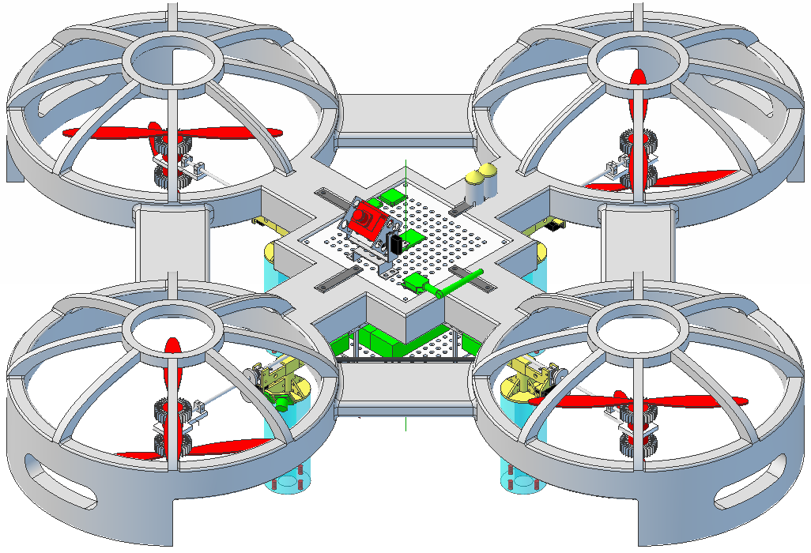
Team Members:
Cory Fulkerson (ME,PM)
John Graham (CpE)
Clayton Hooks (EE)
O’Raphael Okoro (EE)
Tyler Wilson (ME)

May 5, 2011
April 19, 2011

Saluki Engineering Company
Southern Illinois University Carbondale
College of Engineering – Mail code 6603
Carbondale, IL 62901-6604

David Gitz
Fast Robotics
Fast Robotics CEO and ICARUS Lead Engineer
david.gitz@fastrobotics.com

Dear Mr. Gitz

The attached SEC SP11-63-ICARUSLP proposal was made in response to your request for a proposal of an automatic landing pad to extend the range and increase mission duration of the ICARUS vehicle by providing better recharge capabillity.

Upon completion, the automatic landing pad will be able to be transported by the client much like a backpack to a desired location in any environment where the vehicle can operate. The landing pad will effectively communicate with the vehicle, guide it to the pad, charge the vehicle, and then recharge itself via solar panels in order to be able to repeat the process as necessary.

Thank you for taking time to review this proposal and for the opportunity to work on this project. We look forward to working with you in the future. If you have any questions or comments please contact me, at (618) 615-2487, or email cfulker@siu.edu.

Sincerely,

Cory Fulkerson
Project Manager, Team 63
S11-63-ICARUS LP ICARUS Landing Pad Project
Saluki Engineering Company

Saluki Engineering Company
Senior Engineering Design Center
College of Engineering
Carbondale, IL 62901-6603

Automatic Landing Pad
Design Proposal
Prepared for:
Mr. David Gitz

SEC Project #: S11-63-ICARUSLP

Team Members:
Cory Fulkerson (ME,PM)
John Graham (CpE)
Clayton Hooks (EE)
O’Raphael Okoro (EE)
Tyler Wilson (ME)

May 5, 2011

Executive Summary
The Saluki Engineering Company (SEC) proposes to build an Automatic Landing Pad for the Fast Robotics. The landing pad will be portable, charge ICARUS quad rotor flyer, and contain a solar charging system to recover delivered energy. Portability will be considered and addressed in the design of the landing pad. The device will be composed of three subsystems to allow for a more directed and specific design. These subsystems will greatly assist in the build phase as all critical hardware and software will be specified.
The three subsystems of the landing pad are the power system, control system, and mechanical system. Each subsystem has different subgroups. The power system contains the energy collection and energy delivery subsystems, the collection subsystem using solar panels to collect energy and the delivery subsystem using direct contact pads to recharge the ICARUS. The control system will consist of hardware and software, hardware containing the tracking and communication equipment, software containing the guidance and operation code for the landing pad. Finally, the mechanical system will consist of the chassis and transport subsystems. The chassis design process will focus on minimizing weight and size, while the transport portion will be about comfort and ease of movement in transporting it to a location where it will be deployed.
Building the landing pad will be accomplished by the SEC group 63. Initial analysis estimates the cost of the prototype development at $1112. Continued availability of currently specified components and possible design refinements and alterations may ultimately influence this cost. Funds for building the landing pad will be primarily provided from the departments at SIUC. Should the full amount of funding be unavailable, the riskiest and most innovative part of the design will be built as a proof of concept. A schedule has been completed to set tasks to keep the project on schedule. The landing pad will be completed and tested before the end of the fall 2011 semester.

Confidentiality Statement
RESTRICTION ON DISCLOSURE OF INFORMATION
The information provided in or for this proposal is the confidential, proprietary property of the Saluki Engineering Company of Carbondale, Illinois, USA. Such information may be used solely by the party to whom this proposal has been submitted by Saluki Engineering Company and solely for the purpose of evaluating this proposal. The submittal of this proposal confers no right in, or license to use, or right to disclose to others for any purpose, the subject matter, or such information and data, nor confers the right to reproduce, or offer such information for sale. All drawings, specifications, and other writings supplied with this proposal are to be returned to Saluki Engineering Company promptly upon request. The use of this information, other than for the purpose of evaluating this proposal, is subject to the terms of an agreement under which services are to be performed pursuant to this proposal.

Table of Contents
Transmittal Letter (CF) i
Executive Summary (JG) iii
Confidentiality Statement (OO) iv

Introduction (TW) 1
Literature Review
Introduction (TW) 2
Power System 2
Energy Collection (OO) 2
Energy Storage (CH) 2
Energy Conversion (CH) 3
Control System 5
Communication Subsystem (CH) 5
Positioning Subsytem (JG) 5
Primary Controller (JG) 6
Mechanical System 7
Constraints (CF) 7
Panel Deployment (CF) 8
Basis of Design (CF) 9
Project Description
Introduction (CH) 10
Block Diagram (CH) 11
Power System 12
Energy Collection and Storage (OO) 12
Energy Delivery (CH) 13
Control System 15
Navigation and Control Software (JG) 15
Control System Hardware (CH) 16
Mechanical System 18
Chassis and Component Housing (CF) 18
Transport Mechanism (TW) 19
List of Required Actions (CH) 21
List of Deliverables (CH) 22
Organizational Diagram (CF) 23
Required Items List (CH) 24
Validity Statement (OO) 28
Project Timeline (CF) 29
Action Item List (CF) 30
References 31

Appendices
Appendix A – Team Member Resumes 35
Appendix B – Client Correspondence 42

List of Figures
Figure 1: Simplified PWM charge controller toplogy 4
Figure 2: An example application of resonant power transfer 5
Figure 3: An XBEE radio module 5
Figure 4: A motorized sliding door mechanism 8
Figure 5: System-level Block Diagram 11
Figure 6: Major Components of the Power System 12
Figure 7: Major Components of the Control System Software 15
Figure 8: Major Components of the Control System Hardware 16
Figure 9: Major Components of the Mechanical System 18
Figure 10: Summit Straps available for $24.99 19

List of Tables
Table 1: Panel Technology Comparison 2
Table 2: Typical Available Solar Panels 2
Table 3: Storage Battery Options 3
Table 4: Solar Charge Controller Products 3
Table 5: Offline Charger Products 4
Table 6: Possible Charge Transfer Systems 4
Table 7: Available GPS Products 6
Table 8: Vision Products 6
Table 9: Primary Controller Options 7
Table 10: Properties of Materials 7
Table 11: Basis of Design 9
Table 12: Feature Requirements 10
Table 12: Secondary Load Requirements 14
Table 13: Landing Operation Task Sequence 15
Table 14: Device Interface Formats 17
Table 15: Available Shoulder Straps 19

Introduction
The use and production of autonomous aircraft is on the rise. There are growing applications for the use of the vehicles from military surveillance to meteorology. One of the most severe issues with UAV’s is the automation of landing and charging procedures. By implementing a landing pad out in the field, UAV’s will be able to have longer mission durations and more complicated missions.
The objective of this project is to design, document, and prototype an automated landing pad for a quad-rotor unmanned aircraft. The device is to direct the vehicle to properly land the aircraft on the pad. Upon landing, the pad will then charge the battery of the aircraft in a timely manner. The energy delivered to the vehicle is then automatically recovered from an external source, such as a solar panel, allowing continuous operation. The overall system will also be portable so it can easily be moved from place to place with relative ease.
The design of the landing pad will have many constraints. The overall cost of the project should be kept at a minimum, the added weight to the vehicle must be kept very minimal, and the overall concept of the design should be kept very simple as well as light weight and easily maneuverable. The landing pad should be able to safely land and charge the aircraft without the help of manpower and without disrupting the normal operation of the craft.
The proposed landing pad will offer several advantages to the ICARUS vehicle putting it ahead of the competition. The landing pad will allow the vehicle to increases its range and mission duration with a lightweight, self charging pad that requires no little to no maintenance and is completely automated after being placed in the field. The pad will also feature an offline charger to allow the pad to be charged in an office setting before being set out in the field making it ready for use immediately. The landing pad will be able to be easily transported using padded backpack straps, making transportation almost effortless. Once completed, the automatic landing pad will provide an autonomous recharge opportunity for the ICARUS vehicle improving the opportunities and capabilities of the vehicle itself.

Literature Review
This section discusses existing products, technologies, and relevant research, relating their applicability to the design of an automated UAV landing pad. As defined by its intended purpose, the landing pad comprises three major systems:

Power System
- Collects energy for storage
- Stores energy
- Delivers stored energy to the vehicle
Control System
- Communicates with the vehicle
- Guides vehicle through location and landing
Mechanical System
- Provides landing and charging surface for vehicle
- Provides enclosure, support and protection for electronics

Material relevant to each of these systems is discussed in turn.

Power System
Energy Collection
Because the landing pad will be portable, it will need an energy source which is reliable and plentiful wherever it may be used. Applicable to this application by virtue of reliability and compactness, solar panels are the primary focus of this subsystem design. Given the required amount of energy delivered to the vehicle per charge cycle and the amount of time required to recover the energy from the sun, the panels will need to be able to deliver approximately 12 watts in order to conform to requirements.
The panel geometries are loosely dictated by pad dimensions; owing to weight constraints, the panel dimensions should be minimized. The goal is to meet the power requirements (12 W) within a convenient size for assembly and deployment (selected to be approximately 24” square to match the platform dimensions.
Different panel technologies exist and each has benefits and drawbacks. See Table 1 for a basic comparison and see Table 2 for a survey of available 12 volt panels of appropriate size and capacity.

Table 1: Panel Technology Comparison
 | Monocrystalline [5] | Polycrystalline | Thin Film.[4]
Relative cost | Highest | Median | Lowest
Relative efficiency | Highest | Median | Lowest

Table 2: Typical Available Solar Panels
Technology | Capacity | Dimension (in) | Weight | Cost to meet goals | SKU
monocrystalline | 10 W | 14 x 8 | 3.5 lb | $116* [6] | B004FOBJ70
polycrystalline | 10 W | 18 x 13 | 6.0 lb | $320* [7] | 336621
polycrystalline | 10 W | 12 x 12 | 4.5 lb | $162* [8] | BSP10w
polycrystalline | 20 W | 22 x 14 | 5.5 lb | $109 [9] | B001TI6QKK
monocrystalline | 20 W | 17 x 16 | 4.8 lb | $109 [10] | B000VM9H8I
polycrystalline | 31.5 W | 20 x 19 | 10 lb | $125 (approx)** | Team Fabricated
polycrystalline | 63 W | 26 x 28 | 16 lb | $125 (approx)** | Team Fabricated
* composed of two smaller units
** costs are similar due to higher tooling costs for smaller panel fabrication (see Project Description)

Energy Storage
In order to maximize the amount of deliverable energy per solar cycle and allow the vehicle to be charged during dark periods, an energy storage system must be implemented. The nominal stored energy of the vehicle battery is 55 Watt-hours (11.1 V * 5 Ah). With the target for vehicle recharge cycle time being one hour and vehicle flight time being approximately equal, an overnight mission of nine hours with maximum duty cycle (1 hour flight/1 hour charge) would require the storage of 240 Wh.
The obvious candidates for electrical energy storage are batteries. VRLA (valve-regulated lead acid) batteries are low-cost and require relatively simple charging methods, but have relatively low specific energy [11]. Compared to this, NiCd batteries offer a slightly greater energy density (volumetric) and longer life when frequently deep cycled [12]. Nickel Metal Hydride batteries offer a higher gravimetric and volumetric energy density [13]. Lithium-ion variants offer much higher specific energy and cycle life compared to VRLA batteries [14]. These batteries pose greater difficulty in battery management, as they are easily damaged by overcharging and overdischarging conditions [15].
By constraint of specification, the prototype cost and weight are bound by $250 and 30 lb figures. Considering a storage bank operating at nominal 12 V and a discharge rate of 7 A determined by the nominal vehicle charging power (for a one hour charge cycle) and baseline converter efficiency (55 W / (12 V * 65%)), Table 3 outlines the lowest cost options for each technology as located via online resellers.

Table 3: Storage battery options
Type | Typical SE | Target Product | Cost per 20 Ah | Specific Energy | Weight | SKU
VRLA | 28-39 Wh/kg [11] | 12 V 20 Ah | $39 [17] | 34.2 Wh/kg [16] | 14.2 lb [16] | TR20-12
NiCd | 40 Wh/kg | 12 V 20 Ah | $328 [18]* | 45.5 Wh/kg [18] | 11.6 lb [18] | 3759
NiMH | 100 Wh/kg [13] | 12 V 20 Ah | $236 [19] | 74.5 Wh/kg [19] | 7.1 lb [19] | 6085
Lithium | 100-200 Wh/kg [14] | 12.8 V 20 Ah | $151 [20] | 80.0 Wh/kg [20] | 6.6 lb [20] | LFMP20AH
* composed of two smaller units
Where information was available, the products were assessed to ensure that at least 120Wh (the minimum design specification) of capacity could be realized at the previously mentioned discharge rate.

Energy Conversion
As energy is transferred between systems, there are four points at which a battery charger or power supply must be employed. Regulated battery charging systems are required between the solar panels and the battery, between an external input (mains power) and the battery, and between the main battery and the vehicle battery. A small dc power supply will also be needed to operate the control electronics.
The solar to battery conversion may be done in several ways. While a simple linear regulation scheme is easy to build and requires few parts, a boost regulator would allow for charging even at low insolation levels [21][22]. This could effectively increase the amount of energy which could be collected per solar cycle. If a nominal 12 V battery voltage is considered, various available PWM controlled (see Figure 1) charger products on the market can be considered against the possibility of a custom controller design. (Table 4) All the listed controllers are simple step-down types with float voltages suited for lead acid charging; more expensive MPPT and less effective on/off controllers were not evaluated.

Table 4: Solar Charge Controller Products
Max Current | Weight | Cost | SKU
6.6 A | 0.4 lb | $34 [23] | Solsum6.6f
4.5 A | 0.2 lb | $31 [24] | SG-4
10 A | 0.3 lb | $16 [25] | CMP12
10 A | 0.6 lb | $28 [26] | 3966
20 A | 0.2 lb | $45 [27] | SCC3 (kit)
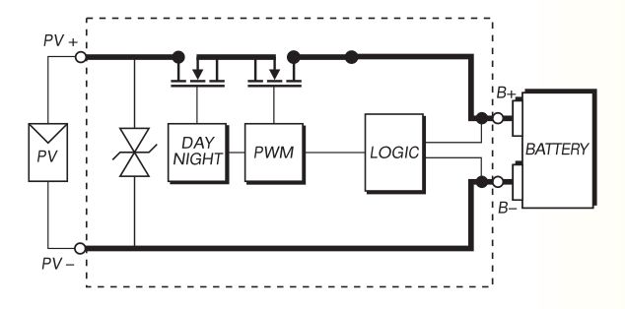
Figure 1: Simplified PWM charge controller toplogy [24]

The landing pad will ideally include some form of external offline charger so that it may be charged prior or subsequent to deployment. Several manufacturers offer relatively low-cost switch mode chargers for each of the previously discussed battery technologies (see Table 5), or a custom design could be developed if time permits.

Table 5: Offline Charger Products
Technology | Max Current | Cost
VRLA | 1.0 A | $16 [28]
VRLA | 3.0 A | $21 [29]
NiCd/NiMH | 1.8 A | $23 [30]
NiCd/NiMH | 3.0 A | $27 [31]
LiFePO4 | 0.7 A | $30 [32]
LiFePO4 | 3.0 A | $21 [33]

The energy stored in the pad battery will need to be transferred to the vehicle when it lands. This is can be done by the use of a contact-based or a wireless transfer system. Table 6 outlines the primary benefits and drawbacks of these methods.
Table 6: Possible Charge Transfer Systems
Method | Bumper Contact | Probe Contact | Induction | Resonance
Advantages | Very simple  Misalignment tolerant | Opposing connector forces allow for more reliable connections | Relatively inexpensive when tightly coupled or at low power levels | Higher efficiency than induction when weakly coupled
Disadvantages | Requires large exposed contacts  Contact force is determined by vehicle weight | Requires either greater landing precision or post-landing coupling engagement mechanism | Low landing precision will reduce efficiency  Higher power levels will impose more weight on vehicle versus contacts | Expensive due to complexity of controls  Higher power levels will impose more weight on vehicle versus contacts
Efficiency range | 85-96%  [34][35][36] | 85-96%  [34][35][36] | 30-80%  [37][38] | 20-95%  [39][40]
Relative Cost | Low | Low | Moderate | High

The primary concerns involved in a contact-based pad design are the same as those for a typical DC connector: connector polarity, contact resistance, and immunity to short circuit or shock hazards. While contact based systems are often implemented for wheeled robots using either a charging probe or open contacts on the charger and/or vehicle body, many applications are often limited to indoor use at low charge currents [41][42]. Low landing precision and possible rotational misalignment make the physical contact interface slightly more difficult to develop for a rotorcraft. Regardless of the physical interface, a contact-based charging system may employ one or more power control stages for the purposes of safely energizing the contacts and performing the required DC-DC conversion and charging.
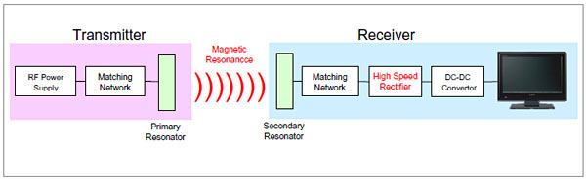
Figure 2: An example application of resonant power transfer [43]

Due to weatherproofing, alignment, and electrical safety concerns, a wireless transfer of the energy from pad to craft is a possible alternative. The wireless power transfer (WPT) methods relevant to this project include inductive coupling and resonant power coupling (RPC). The use of resonant LC networks in the sending and receiving units allows RPC to have a greater transfer efficiency across relatively large air gaps when compared to magnetic induction alone [37]. The primary drawback of using RPC is its complexity over the alternative, ideally utilizing a resonant driver configuration operating at ZVS/ZCS conditions and controlled impedance matching (Figure 2) to maintain coupling efficiency for a variable load [38][44].

Control System
Communication Subsystem
In order to communicate with the deployed vehicle(s), the landing pad requires a relatively long range radio device. The selection of this device is constrained primarily by the radio products used in the vehicle and base station.
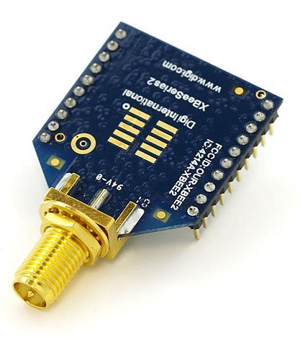Figure 3: An XBEE radio module [45]

Compatible with to the existing system radio, the 63mW XBP24-ASI-001 (Figure 3) has an outdoor range approaching one mile [45]. The module features a serial interface which can subsequently be adapted to various interface formats [46]. The documentation for such interface conversion is available from the manufacturer and pre-assembled adapter cradles are available at low cost.

Positioning Subsystem
As the ICARUS flying device needs to land and recharge, locating its position in relation to the landing pad will be an important part of the process of the landing sequence. An on-pad GPS system will allow the landing pad to relay its location to the vehicle. A close-quarters positioning system can then be used to guide the flying craft into position on top of landing pad.
Low cost GPS receivers such as those in Table 7 have been created and have proven useful for small robotic tracking tasks. The typical operational mode of the GPS is to decode pseudo-ranges from all viewable satellites in the sky in the receiver and then calculate the position on earth. The calculation can be inaccurate and is subject to errors due to problems calculating satellite positions, due to delay in signal paths, and clock synchronization. [47].

Table 7: Available GPS Products
Specification | EM-406A | EM-408
Receiver Type | 20 Channel Receiver | 20 Channel Receiver
Antenna Type | Built-in antenna | Built-in antenna
Sensitivity Rating | -159 dBm | -159 dBm
Accuracy | 10' Positional /5' with WAAS | 10' Positional /5' with WAAS
Hot Start | 8 seconds | 8 seconds
Warm Start | 38 seconds | 38 seconds
Cold Start | 42 seconds | 42 seconds
Power Consumption | 44 mA | 75 mA
Voltage Operation | 4.5- 6.5 V | 3.3 V
Size | 30 mm x 30 mm x 10.5 mm | 20 g weight
Status indicator | Built-in LED | Built-in LED
Connector | 6-pin interface cable | 5-pin interface cable
Operating temperature | -40℃ to +85℃ | -40℃ to +85℃
Cost | $59.95 [48] | $64.95 [49]

A machine vision system is a common solution for the final landing positioning and is the focus of this research. Using a compact video camera, the controller could be able to identify and track the alignment, distance, and rotation of the vehicle WRT the pad. The selection of the optics system depends on the nature and variability of its target and background. A vehicle mounted camera may be more effective than a pad mount, given that a pad mounted camera is subject to sun glare. Currently, the responsibility of vision processing should not be placed entirely on the vehicle’s computer. The CMU cameras (Table 8) are designed to track color blobs and then relay their coordinates to a serially connected (RS-232) device. This simplifies the task of coding the vision processing system and may later simplify the use of an inexpensive microcontroller-based control system.
Table 8: Vision Products [50]
Specification | CMUcam1 | CMUcam2
FPS | 17 FPS | 50 FPS  Track motion at 26 FPS
Resolution | 80x143 | 160x255
Price | $109 assembled | $179.00 assembled

Also, currently installed on the ICARUS flying device are MaxBotix SEN-08503 ultrasonic sensors. These 42 kHz sensors have a range from 6 to 254 inches and will allow the vehicle to carefully close the final distance in the landing process as it becomes too close for fixed optics to maintain focus [51].

Primary Controller
A primary controlling device is required to perform the logical communication with the vehicle and sequence various circuits in the landing pad including power supplies, chargers, and possibly motors.
A microcontroller is a small computer on a single inexpensive integrated circuit containing a processor core, memory, and programmable peripherals (Table 9). They may use very little power, but having a relatively low clock frequency, narrow data path (8-16 bit), and often lacking FPU functionality, a small microcontroller may be difficult to develop for applications involving real-time processing of large amounts of data.
Single board computers are complete computers built on a single circuit board (Table 8). Used most commonly in industrial situations where they are used for process control or with other devices to provide control and interfacing. Because of their simplicity, they are often lighter, smaller, more power efficient and reliable compared to full computer systems.
A possible advantage of using a laptop for the landing pad control would be that it would reduce the cost of initial development. If a SBC is integrated into the design at a later date, any control system used with the laptop could be simply connected to the SBC without modification.

Table 9: Primary Controller Options
 | 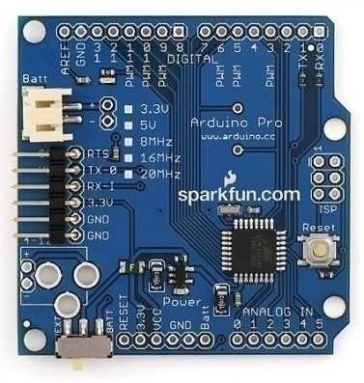 | 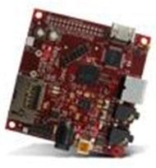 | 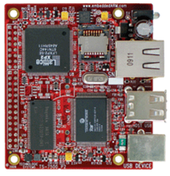
Classification | Microcontroller | Single-board computer | Single-board computer
Product | Arduino Pro 328 [52] | Beagleboard [54] | Technologic TS-7500
Processor | 16 MHz Atmega328 | 720 MHz OMAP3530 | 250 MHz ARM9
RAM | 2 KB SRAM | 256 MB SDRAM | 64 MB SDRAM
NV Storage | 32 KB Flash + 1 KB EEPROM | 256 MB Flash + SD card | 4 MB Flash + SD card
Relevant Features | PWM and ADC on-chip | PWM and GPIO onboard | PWM and GPIO onboard
Power Use | 5 v/9 mA typical | 5 v/400 mA typical | 5 v/400 mA typical
Dimensions | 2.1 in x 2.0 in | 3.1 in x 3.0 in | 2.6 in x 3.0 in
Cost | $20 [53] | $125 [55] | $139 [56]

Mechanical System
Constraints
The chassis will house all the batteries and necessary electrical components which ultimately allow a platform for the vehicle to land on and charge. Not only will it house the electrical components but it will also be the frame onto which the solar panels will be attached. Due to the varying environment conditions the landing pad may be introduced in and the constraints placed on the pad itself, the chassis needs to be rugged, weatherproof, compact, and lightweight in order to withstand the environment it’s placed in, protect the electrical components within it, and be easily transportable.
The chassis, the backbone of this entire project needs to be lightweight, and compact to allow for easy transportation of the pad by a single person. The ideal way to transport the pad would be much like a suitcase or backpack. Due to the uniqueness of this project, similar concepts were researched in order to get a feel for the type of materials being used for rugged, outdoor use, boxes.
Table 10: Properties of Materials [57]
Material | Density | Modulus Of Elasticity | Yield Strength | Tensile Strength | Cost
 | (g/cm³) | (Gpa) | (Mpa) | (Mpa) | ($US/kg)
Aluminum | 2.71 | 69 | 34 | 90 | 7.25-11.35
Carbon Steel | 7.85 | 207 | 220-250 | 400-450 | 1.75-1.95
Stainless Steel | 8 | 193 | 205 | 515 | 2.15-3.50
Titanium | 4.51 | 103 | 170 | 240 | 28-65
Polypropylene | 0.905 | 1.14-1.55 | 31-37.2 | 31-41.4 | 0.85-1.65
Carbon Fiber | 1.78 | 230 | N/A | 3800-4200 | 31.5-41.5

Therefore, toolboxes were researched which provide a similar application to tools as the chassis will to electrical components. The most common materials for tool boxes were plastic, steel, and aluminum. Therefore common properties of these materials along with a few others are shown above in Table 10.

Panel Deployment
A major concern of the landing pad design is where to attach the solar panels in order to allow them to always be collecting solar energy, yet allow for a compact and sleek design. While the solar panels may be fixed or manually positioned when the system is placed in the field, an automated panel deployment system may provide extra functionality.
One way to approach this is to implement the use of automatic sliding doors much like the ones used in many commercial buildings. This will allow for the solar panels to act as doors and always be facing up toward the sun and will enable the pad to close when not in use. When the pad is not charging the vehicle, the solar panel doors will close, protecting the other components of the landing pad. Shown in Figure 4 is the basic schematic of how an automatic door system works. There is an electric motor with a drive pulley which is collinear with another stationary pulley. A closed loop belt goes around the two pulleys as shown. When the motor applies a torque to the belt, the top and bottom of the belt move in opposite directions as shown in the figure as points A and B. The doors are attached to these points which are shown in the figure as M_{D} and the motion of points A and B cause the door to open or close depending on the direction of rotation.
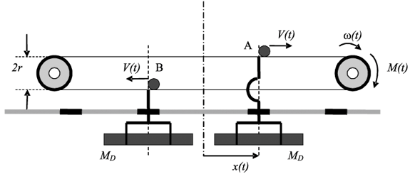
Figure 4: A motorized sliding door mechanism [58]
Now all that is needed to complete this system is a frame and railing system onto which the solar panel doors can be attached and guided. In this application, the doors will be mounted horizontally as opposed to the position shown. A low profile railing system mounted horizontally with a flat mount will be simple to implement for this particular application.
An alternative method would be to pivot the panels into their operating position. If the pad were constructed in a manner which allowed the panels to be hinged upon its edge(s), then servos or other electromechanical actuators could be used to position the panels at any angle between fully closed and fully open. Since the energy available to a solar panel varies as a function of its angle to the incident sunlight as per , angular control of the panels would be beneficial. With a directional light sensor array similar to a heliostat controller, each panel could independently be positioned to maximize its angle with the incoming sunlight. Although this deployment method has a unique benefit, its disadvantage lies in the requirement of extra actuators and an additional sensor system for independent panel positioning.
The solar panels could also be treated as a separate component and could then just be plugged into the landing pad when set out in the field ready for use. Of course, with such a design, the solar panels could easily be forgotten and this design would also require more setup time when compared with the design of mounting the solar panels fixed to the landing pad.
Basis of Design
Table 11: Basis of Design
Documents | Date
Request for Proposal (RFP) | Feb. 15, 2011
SEC RFP Project Definition | Feb. 15, 2011
SEC RFP Design Report Deliverables Checklist | Feb. 15, 2011
Team 63 Proposal | Apr. 19, 2011

Project Description
The target requirements of the proposed landing pad design have been specified and are reviewed in Table 12 below.

Table 12: Feature Requirements
Parameter | Target | Goal
Communications | ICARUS Protocol
Control System | External Computer | Embedded System
Production Cost | $250 | $150
Transport | Hand Carry | Back Carry
Landing Time | 60 seconds | 30 seconds
Weight | 30 lb (13.6 kg) | 20 lb (9.07 kg)
Weatherproofness | Mild Weather | Normal Weather
Storage Capacity | 10 Ah | 20 Ah
Vehicle Charge Time | 60 minutes | 40 minutes
Charge Recovery Time | 6 hours | 4 hours
Vehicle Weight Add'n | 1 lb (454 g) | 0.75 lb (340 g)

The landing pad will be composed of three main system groups. A power system will be responsible for the collection of solar energy at a rate sufficient to recover 71 Wh within four to six hours, and its delivery to the vehicle at a rate sufficient to meet a one hour charge time. A control system will be responsible for accurate and timely navigation/guidance of the vehicle during the location and landing process, as well as subsequent power supply sequencing. Finally, a mechanical system will be required to house and weatherproof the other components of the landing pad and to provide the device with a practical means of transport to and from the field. Each of these systems can be conceptually composed of subsystems based on the primary roles of the system. These roles are listed as follows, depicted in Figure 5, and are discussed in depth in the subsequent system descriptions.

Power System
- Energy collection and storage
- Energy delivery
Control System
- Hardware
- Software
Mechanical System
- Chassis
- Transport

System-Level Block Diagram

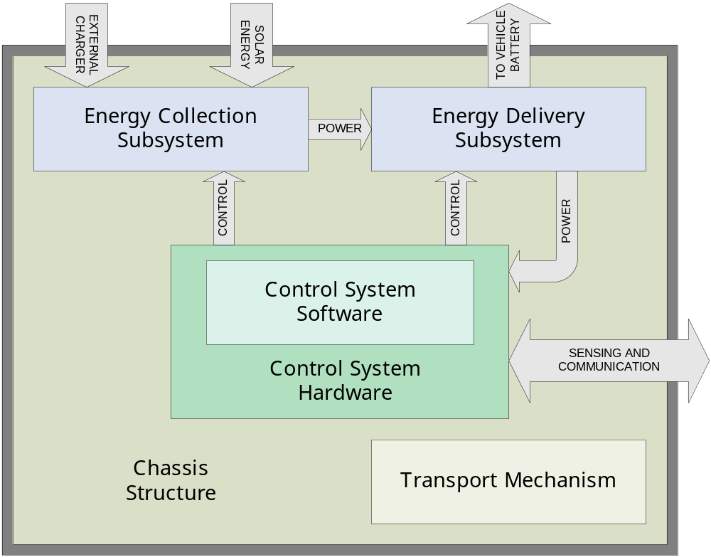Figure 5: System-level block diagram

Power System
The power system is characterized by its two major functions, and can be conceptually composed of subsystems responsible for each. These subsystems are the energy collection/storage subsystem and the energy delivery subsystem. These subsystems are illustrated in Figure 6.

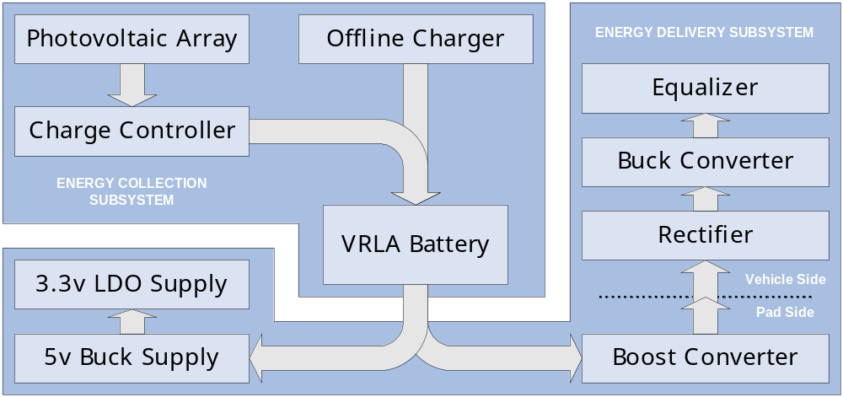Figure 6: Major Components of the Power System

Energy Collection and Storage
The energy collection subsystem is responsible for collecting energy from various external sources and storing it in an onboard battery for later use. The resources from which this subsystem gathers energy include the sun and an external energy resource such as an offline charger or power supply. The major components of this subsystem are photovoltaic (PV) panels, a PV charge controller, a storage battery, and an offline charging facility.
The solar energy is to be collected by a pair of 15W monocrystalline PV panels connected in parallel. These panels’ high efficiency and higher total current capacity will ensure the necessary amount of energy can be collected even during widely variable sky conditions and insolation angles, given the necessary 12W requirement obtained per the following:

While PV panels could be constructed from standard 3x6 cells (Table 2), this would require the additional expenses associated with frame materials, glass, and diamond saw rental (necessary for halving cells in order to make an appropriately dimensioned panel). The selected panels are assembled with aluminum channel frames, lending them the structural integrity necessary to support themselves on their deployment mechanism without the necessity for an additional support structure.
The energy collected by the solar panels will be delivered to the storage battery by means of a PV charge controller. The charge controller will regulate the average current delivered to the battery by means of PWM control of a series MOSFET, in effect allowing a photovoltatic array to be utilized as a three-mode battery charger. This type of charge controller is more effective than simpler on/off controllers, and owing to its relative simplicity, it is very inexpensive compared to MPPT type controllers. A series PMOS FET will be used to block the reverse current flow which would otherwise occur when panel voltage dropped below the battery voltage at night. This is ultimately more efficient than the use of high current silicon rectifiers for night blocking, as the Rds_on losses of the FET during conduction are typically lower than the losses associated with a diode with large V_forward.
To minimize cost, lead-acid battery technology will be used as opposed to a lithium or nickel secondary battery (see Table 3 for relative option costs). An Amstron AP-12220EV 12v/22Ah VRLA battery will be used to satisfy the bulk storage requirements of the landing pad. This battery can store more than the 240 Wh specified by the requirements, and the extra capacity should help ensure that this capacity can be realized even with age, high discharge currents, or nonideal temperature conditions. The VRLA chemistry was selected due to its durability and relatively wide operating temperature range. The selection of replacements in this chemistry and particular case style is very wide. While, at 14 lb, this battery does significantly impact the overall weight of the landing pad, its low cost, deep-cycle rating and case type were primary factors influencing the selection of this specific model. If at a later time, the design is to be revised for the use of a lighter, more expensive LiFePO4 battery, such units are available in the exact same case and would require only a minimal addition of charge protection circuitry.
In order to charge the battery prior or subsequent to deployment, a facility for charging the battery will be made for connecting to an offline charger. This connection will be made via a weatherproof polarized chassis connector properly rated for the required charge currents.

Actions
- Experimentally verify system collection capacity in actual application
- Finalize hardware design
- Assemble chassis wiring harness
- Integrate panels into panel support mechanisms
- Complete final documentation, specifications and usage instructions
Deliverables
- Assembled components
- Wiring diagrams and schematics
- Detailed specifications and documentation
- Instructions for installation and use

Energy Delivery
The power delivery subsystem is responsible for transferring the energy stored in the landing pad's battery to the Li-Poly battery carried by the vehicle as well as to secondary loads within the landing pad.
For the sake of cost, efficiency and simplicity (in comparison to contactless power transfer), power will be coupled to the vehicle by means of exposed metallic contacts on the pad surface and on the vehicle's landing bumpers. The proposed exposed contact system will allow for lower landing precision than a probe type contact system may require. As the source battery voltage may be either above or below primary load (vehicle battery) voltage requirements depending on its state of charge, the primary load path will need to incorporate both step-up and step-down capabilities. The pad-side half of this coupling will perform the step-up operation (to 20 volts), while the vehicle-side half will independently perform step-down operation (to approximately 12.6 volts/7A). Though this is slightly less efficient than some possible applications of a single buck-boost converter, there are a few advantages. By separating the operations into two different assemblies, a robust converter can be made to operate at a significant current across a wide range of input voltages (possibly requiring the use of heavier magnetics, capacitor banks or heat sinks) without the necessity to incorporate all of the weight in the vehicle-side assembly. Second, by performing the boost operation first, the current through the pad contacts is minimized. Lastly, the use of independently controlled converters eliminates the need to pass control feedback through the radio link, ensuring output stability and reducing the vehicle's control system activity during the charging operation. Since the pad coupling utilizes open contacts, provision must be made to de-energize the pad-side contacts when they are not in use or if an overcurrent fault should occur. Provision will also be made on the vehicle-side assembly for the automatic rectification of the input voltage, as incorrect polarization would otherwise be a hazard due to the craft and contact array having square symmetry. Finally, since the vehicle's battery is a li-poly battery designed for high current and low weight applications, it lacks an internal circuit for cell protection and equalization. As the vehicle-side assembly will become the primary charging system for this battery, it will incorporate a 3 W/cell equalizer and protection circuit, ultimately interfacing directly with the battery's equalizing/charging harness.

Table 13: Secondary Load Requirements
Load | 3.3v load currents | 5v load currents
UVLO/OCP controller | No load | 8-40 mA
GPIO controller | No load | 25-200 mA
UART level shifters | No load | 15-144 mA
USB hub controller | 20-200 mA | 20-350 mA
XBee XBP24-ASI-00 | 55-340 mA | No load
Skytraq Venus 634 GPS | 28 mA | No load
CMUcam | No load | 200 mA
WORST CASE TOTAL | 568 mA | 934 mA
TOTAL SECONDARY LOAD | 1502 mA on 5v supply
Total load current appears on 5v supply since 3.3v supply is linear (I_{IN} ~ I_{OUT}) and it is derived from the 5v output
LDO quiescent current < 0.5 mA, neglected in these and further calculations

The secondary loads involved in the landing pad include the UVLO/OCP controller on the pad-side coupling assembly, as well as the various loads involved in the control system assembly. The voltage and current requirements among these loads are illustrated in Table 13 and can be satisfied by the incorporation of a single regulated 5v supply capable of approximately one amp and a second regulated 3.3v supply capable of approximately 600 milliamps. For efficiency, a small 5v, 2.2A buck-type switching regulator based on the LTC1938 will provide the bulk of the power to all secondary loads. The 3.3v supply will be provided from this 5v supply by a downstream linear regulator. This allows the use of an inexpensive and simple linear regulator while minimizing the power loss that would otherwise occur with a higher input voltage.

Actions
- Experimentally verify source battery losses across discharge curve so that charge current can be set to maximize source battery capacity
- Develop dummy load for charge time verification
- Finalize hardware design
- Complete schematic capture, PCB layout, CAM generation
- Fabricate and test prototype assemblies
- Perform any required design/layout revision
- Complete final documentation, specifications and usage instructions
Deliverables
- Schematic, PCB layout and CAM files
- Source code for charge termination and UVLO/OCP controllers
- Detailed specifications and documentation
- Instructions for installation and use
- Prototype PCA's

Control System
The control system is responsible for communication and proper guidance of the vehicle, as well as the management of the power systems. The control system is composed of a software subsystem and its hardware interface as illustrated in Figures 7 and 8.

Navigation and Control Software
The navigation software will be written in C++ programming language. The program will be an object oriented program using classes to define the different operations of the software. The software will be responsible for controlling the hardware for the landing procedure. The software will be designed using a class structure where each class will define and operate a different task or operation in the landing sequence.

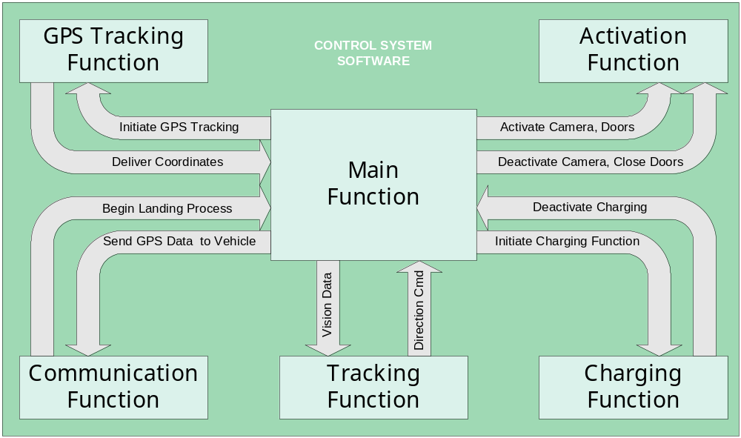
Figure 7: Major Components of the Control System Software

There will be 5 main class functions, the GPS data, Activation/deactivation, communication, tracking, and charging function. The overall goals of the software engineering will to be to create a program that is easily modifiable and compatible with the ICARUS protocol onboard the ICARUS flying device. The software will step through the following steps (Table 14) in this order for the landing sequence.

Table 14: Landing Operation Task Sequence
- Receive signal from ICARUS flyer signaling approach
- Initiate Startup
  - Initiate startup of GPS device and receive location to memory
  - Open solar doors (if automatic deployment implemented)
  - Activate CMUcam and begin calibration (if required)
- Transmit location of Landing Pad to flyer
  - Await acknowledge and arrival signals
- Begin landing sequence
  - Begin tracking using CMUcam
  - Calculate distance and orientation
  - Transmit location of flyer in X, Y and Z coordinates
  - Continue tracking distance and direction until touchdown
- Activate Charging sequence
  - Activate charging nodes
  - Monitor charger status
  - Disable charging system
  - Disable CMUcam
- Takeoff
  - Receive takeoff notice from vehicle
  - De-energize pad contacts (if still charging)
  - Wait for clearance verification from vehicle
  - Close solar doors
  - Continue recharging batteries
  - Begin waiting for signal to begin landing sequence

Actions
- Create C++ code for navigation systems.
- Test and simulate code
- Test system with hardware to ensure compatibility between systems
- Full system test with flyer to ensure proper functionality
- Complete final documentation, specifications and usage instructions
Deliverables
- Source code and final binaries
- Detailed specifications and documentation
- Instructions for installation and use

Control System Hardware
The control system hardware comprises a number of peripherals, two distinct printed circuit assemblies, and a controlling computer. The major assemblies of the control system are the landing illuminator and the control system assembly.

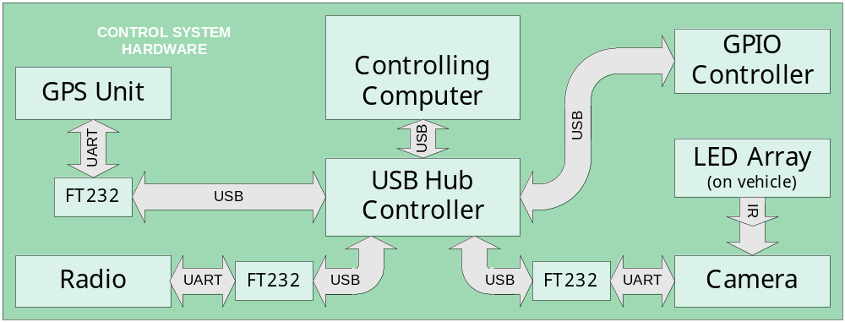Figure 8: Major Components of the Control System Hardware

The peripherals utilized in the control system include an XBee-Pro 802.15.4 radio module, a Skytraq Venus634 GPS development module, and a CMUcam color sensing camera. The XBee radio is a serially-connected 2.4 GHz radio module, and is the primary means of communication with the vehicle. The Venus 634 is a 65 channel GPS receiver. This device is required so that the control system can relay its coordinates to the vehicle when a landing request is made. This unit was selected due to its low cost and the availability of development resources in various online forums. The CMUcam consists of a small CCD camera with an onboard microcontroller. Properly configured, the camera can be used to track regions of selected color, providing the tracking coordinates via a serial interface. This will allow the control system to track the location, range, and orientation of the vehicle during the descent procedure. The basis for the specific model selection (CMUcam2) is merely a matter of available resolution and framerate. The higher resolution and framerate will help reduce overshoot error and rotational misalignment during the landing procedure.
The landing illuminator assembly (LIA) consists of a control board and four clusters of LED’s to be mounted in an array on the vehicle in a manner which will allow the vision system to more easily resolve the location, range, and orientation of the vehicle against variable sky conditions. The control board provides the LED clusters with a regulated current from the vehicle battery and can be enabled by means of a logic level signal from the vehicle control computer. LED’s are available in a wide range of colors and power ratings. To a degree, the design of the assembly will be dictated by the type of LED’s selected. Experiments must be made to determine the optimal color/power characteristics, given the response of the selected camera.
The controls system assembly (CSA) consists of the control system peripherals and the hardware required to interface them to a common primary controller. The peripherals involved in the CSA include the communications equipment (GPS unit and XBee-Pro radio), as well as the vision system (CMUcam) and a USB-capable general-purpose I/O (GPIO) controller. The specifications of these devices are illustrated in Table 15. To allow for the flexibility of a modular design, each of these peripheral devices will have its data interface adapted from its native UART levels to a standard USB interface with the use of a Future Technologies FT232 level-translator. An integrated USB hub controller will allow for a single-cable interface to be made between the CSA and an external control device.

Table 15: Device Interface Formats
 | Device | Supported Interfaces
GPIO controller | Atmel AT90USB162 | USB | 3.3v/5v SPI
Radio | XBee XBP24-ASI-001 | 3.3v UART
GPS | Skytraq Venus 634 GPS | 3.3v UART | 3.3v SPI
Camera | CMUcam V1/2 | 5v UART | RS232

For the purpose of development, the primary control will be performed by an external laptop computer; however, the commonness of the USB interface will allow it to be later interfaced with any USB-enabled microcontroller or single-board computer with minimal code modification. This would allow the system to then become self-contained.
Actions
- Experimentally verify contrast resolution and focusing performance of the CMUcam in specified conditions
- Experimentally verify optimum targeting color(s) and ranges
- Finalize hardware design
- Complete schematic capture, PCB layout, CAM generation
- Fabricate and test prototype assemblies
- Perform any required design/layout revision
- Complete final documentation, specifications and usage instructions
Deliverables
- Schematic, PCB layout and CAM files
- Source code for GPIO microcontroller
- Detailed specifications and documentation
- Instructions for installation and use
- Prototype PCA's

Mechanical System
The mechanical system provides enclosure and support for the components of the other systems and facilitates their practical transport to and from the field. The mechanical system is composed of the chassis structure and a transport mechanism as conceptually depicted in Figure 9.

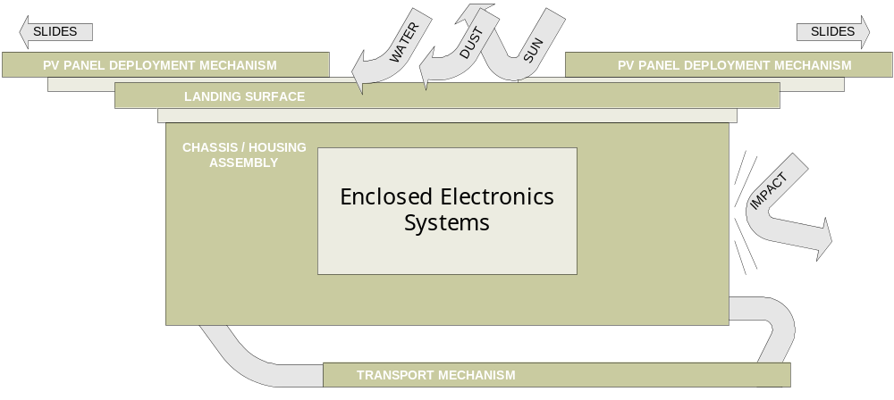Figure 9: Major Components of the Mechanical System

Chassis and Component Housing
The chassis serves as the backbone to the whole landing pad and will be made of one quarter inch ABS plastic in order to provide a robust and lightweight frame that is easily transportable and will be able to withstand the various environments and wear and tear it will be introduced to.
The function of the chassis and electrical component housing subsystem is to provide both a platform for the vehicle to land on, as well as to serve as housing for all the necessary electrical components. The chassis will have a removable lid which, when removed, will allow access to the landing pad batteries, charging systems, controllers, and other systems integrated into the landing pad. The lid will provide a seal between the electrical components and the outside environment to protect them from dust, water and various other particles which may disable or destroy such systems. The landing pad chassis will also feature conical radii which will act much like a cup to catch the vehicle as it lands. Such guides help position the vehicle in the correct spot when landing to allow for the most efficient charging.
The solar panels will also be mounted on to the chassis as well through drawer slides in order to provide a design which can be compact and easily transported when not in use yet, can be manually opened when placed in the field to expose a place for the vehicle to land safely and recharge. By integrating the solar panels into the chassis with drawer slides, this allows the landing pad and vehicle to be able to charge at the same time make both the pad and the use of the solar energy per day more efficient. The solar panels will also feature magnetic latches integrated into them to keep them in their open or closed position. This will be an important detail to pay attention to incase the landing pad is set on unlevel ground causing the solar panels to tend to close on their own preventing the vehicle to be able to land and recharge. It is also important to ensure the solar panels are latched in place while transporting the landing pad to and from its needed location so that the solar panels do not open and get snagged on an obstacle causing them to break.

Actions
- Perform stress analysis of chassis
- Finalize CAD Drawings
- Purchase parts and assemble
- Test chassis functionality with vehicle landing
Deliverables
- CAD drawings of Chassis/Housing Assembly
- Individual CAD drawings/Schematics of parts with dimensions
- Parts List
- Detailed specifications and documentation
- Instructions for installation and use

Transport Mechanism
The landing pad must be transportable from landing zone to landing zone. In order to make this possible, many different possibilities were brought up to the team. Possibilities of simple nylon straps to elaborate padded backpack straps hung from the bottom of the landing pad were discussed with all team members.
The proposed mechanism for transport is a pair of backpack-type shoulder straps (similar to those in Figure 10). These straps will be connected on the sides of the landing pad so when the pad is setting in its position the straps could be either disconnected or moved off to the side to avoid an imbalance with the automated landing pad. These are padded straps that add comfort and simplicity for hauling the landing pad. These straps can be easily attached with some nuts and bolts to the side of the pad. Several different companies make these straps; available products are reviewed in Table 16.

Table 16: Available Shoulder Straps
Vendor | SKU | Cost | Benefits
Amazon | B000AAFF7I | $7.60 [59] | Lower cost
Shooter’s Warehouse | ACU-61001-4 | $26.99 [60] | Non-absorbent rubber padding
Woodbury Outfitters | 71694385057 | $24.99 [61] | Soft foam padding

For sake of cost, the $7.60 straps shown in Table 16 will be utilized for the purpose of transporting the assembled landing pad.

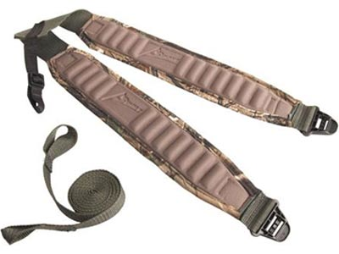
Figure 10: Summit Straps available for $24.99 [61]

Actions
- Finalize CAD Drawings
- Purchase parts and assemble
- Test transport subsystem functionality with loaded chassis
Deliverables
- CAD drawings of Transport Assembly
- Parts List
- Detailed specifications and documentation
- Instructions for installation and use

List of Required Actions
- Experimentally verify system collection capacity in actual application
- Experimentally verify source battery loss figures (Peukert’s number) so that charge current can be set to best meet charge & recovery time goals
- Develop dummy load for charger & equalizer verification
- Experimentally verify contrast resolution and focusing performance of the CMUcam in specified conditions
- Experimentally verify optimum targeting color(s) and ranges
- Perform stress analysis of chassis
- Finalize hardware design for:
  - Energy collection path components
  - Pad Side Coupling Assembly (PSCA)
  - Vehicle Side Coupling Assembly (VSCA)
  - Secondary Power Supply (HKPSU)
  - Landing Illuminator Array (LIA)
  - Control System Assembly (CSA)
- Finalize CAD drawings for chassis & transport assemblies
- Create C++ code for navigation systems.
- Test and simulate code
- Purchase parts and assemble chassis & transport assemblies
- Complete schematic capture, PCB layout, CAM generation for power and control system assemblies
- Fabricate and test prototype assemblies for power and control systems
- Test software system with hardware to ensure compatibility between systems
- Perform any required design/layout revision of prototype assemblies
- Test transport subsystem functionality with loaded chassis
- Full software/hardware system test with flyer to ensure proper functionality
- Test chassis functionality with vehicle landing
- Complete final documentation, specifications and usage instructions for each system:
  - Drawings & CAD/CAM files relevant to each system
  - Comprehensive parts lists
  - Technical specifications & design documentation
  - Instructions for proper use & assembly

List of Deliverables
- Wiring diagrams for assembly interconnection & chassis/vehicle wiring
- Schematic, PCB layout and CAM files (Excellon/Gerber) for all designed assemblies:
  - Pad Side Coupling Assembly (PSCA)
  - Vehicle Side Coupling Assembly (VSCA)
  - Secondary Power Supply (HKPSU)
  - Landing Illuminator Array (LIA)
  - Control System Assembly (CSA)
- Prototype PCA's:
  - Pad Side Coupling Assembly (PSCA)
  - Vehicle Side Coupling Assembly (VSCA)
  - Secondary Power Supply (HKPSU)
  - Landing Illuminator Array (LIA)
  - Control System Assembly (CSA)
- Source code and final binaries for:
  - Primary control system software
  - Charge termination microcontroller (on VSCA)
  - UVLO/OCP microcontroller (on PSCA)
  - GPIO microcontroller (on CSA)
- CAD drawings for mechanical system assemblies:
  - Chassis/Housing Assembly
  - Transport Assembly
  - Individual CAD drawings/Schematics of parts with dimensions
- Detailed specifications and documentation
  - Parts Lists for all systems and assemblies
  - Nominal and maximum ratings
  - Technical Manual for each system
  - Instructions for use and installation
- Cost to implement
- Schedule of implementation

Organizational Diagram
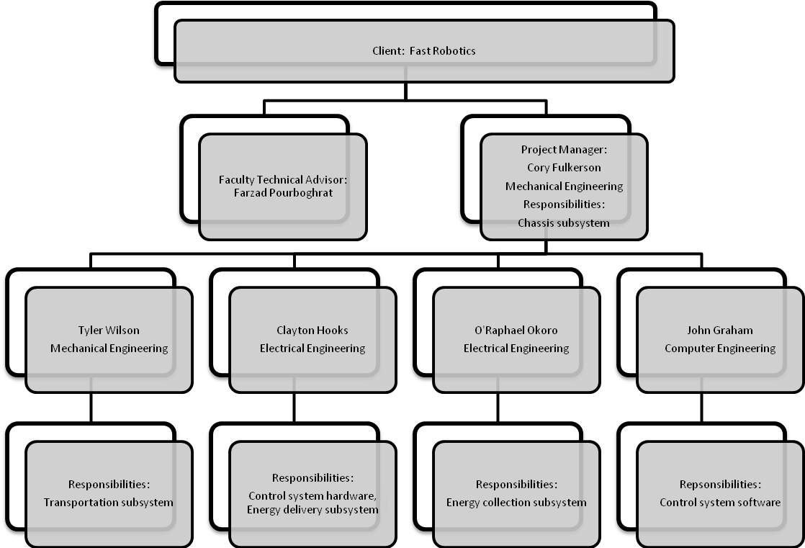

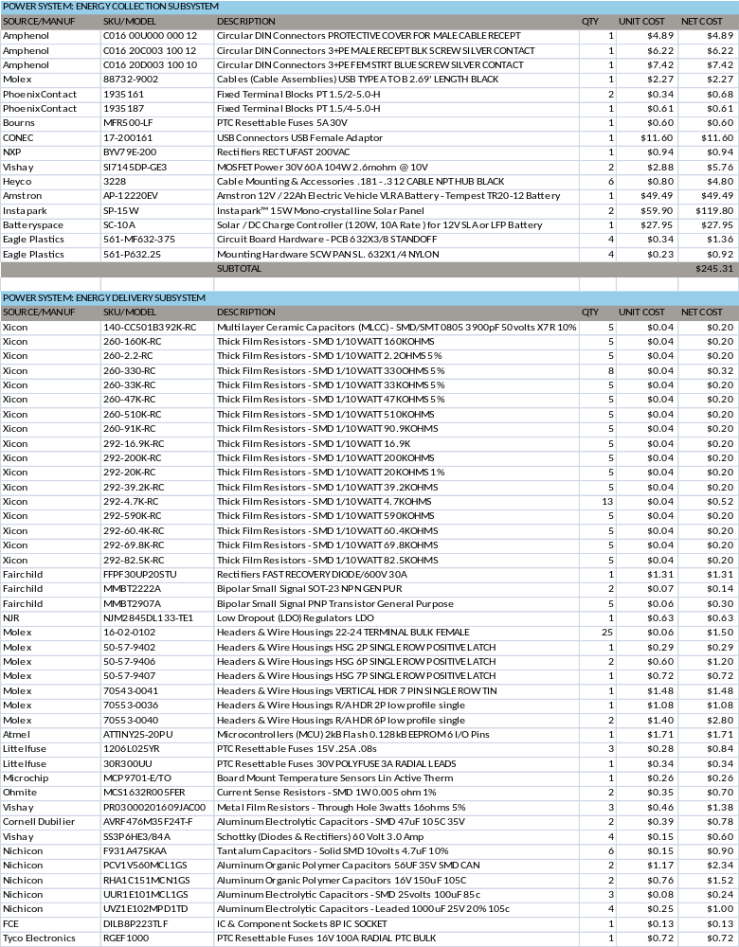
Required Items List

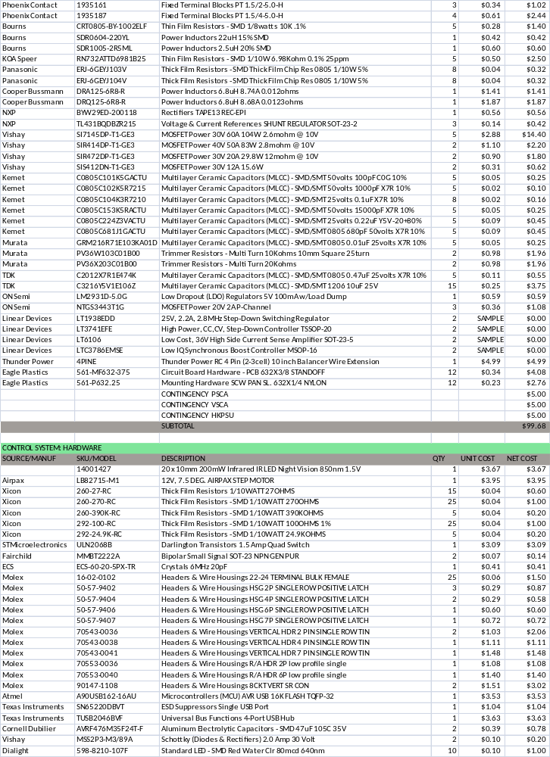
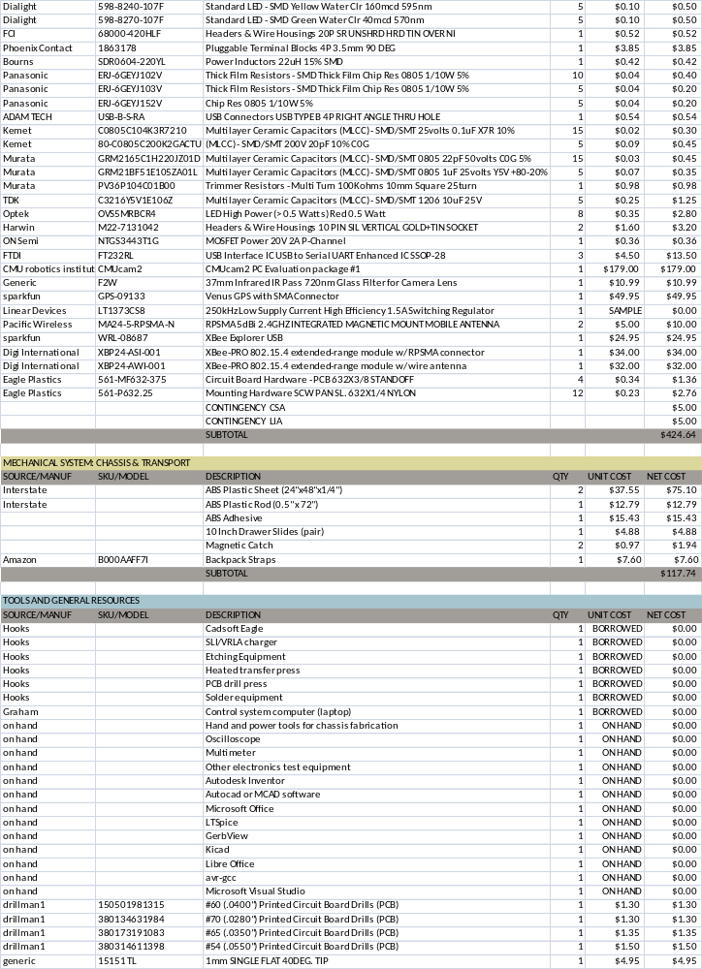
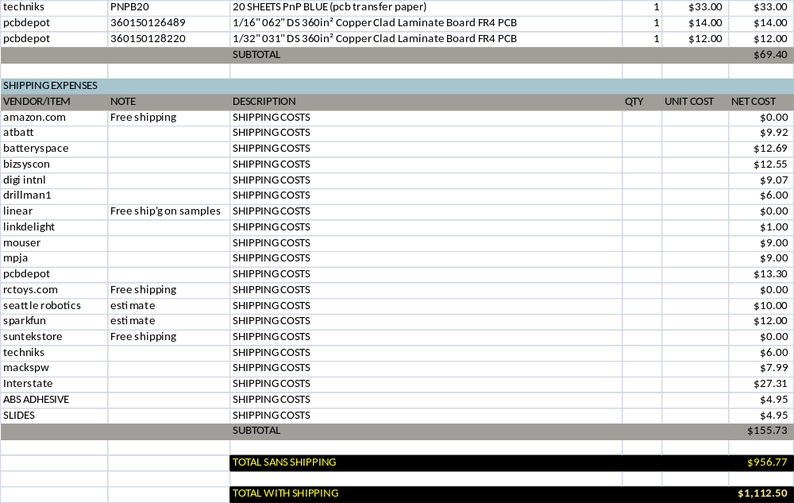

Validity Statement
This proposal is valid for a period of 30 days from the date of the proposal. After this time, Saluki Engineering Company reserves the right to review it and determine if any modification is needed.

Project Timeline

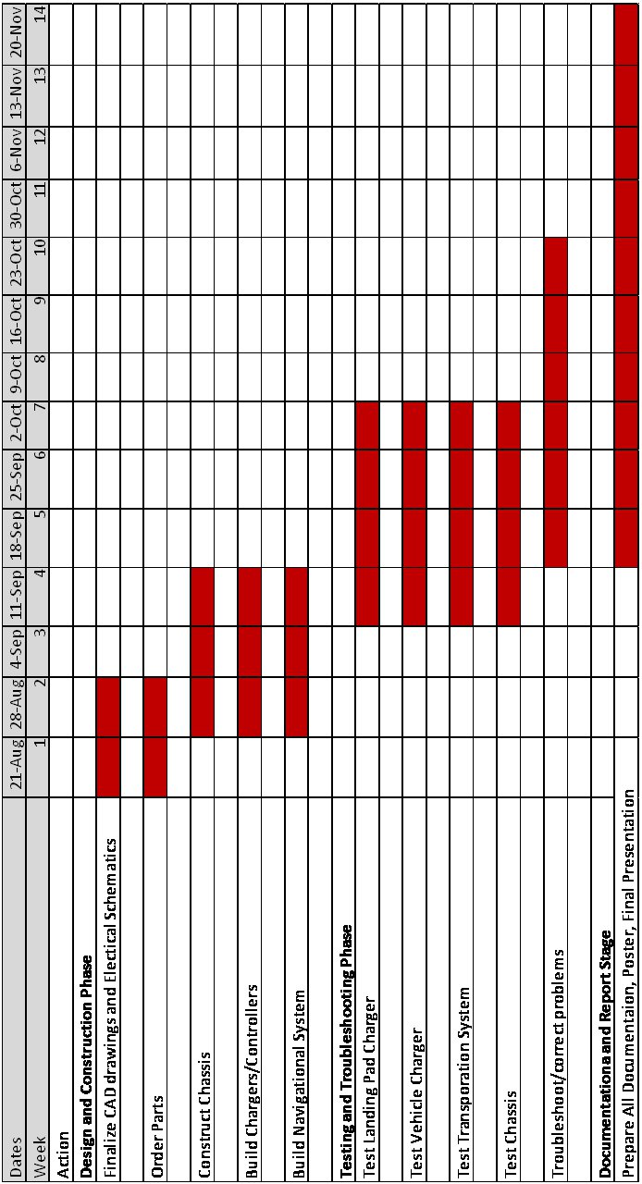

Action Item List

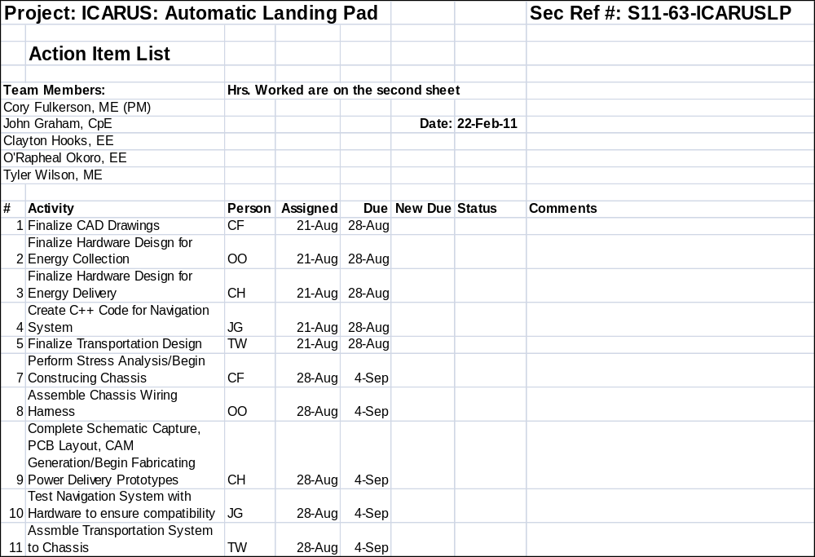

References
[1] Nourghassemi, Behnam. “Development of the control algorithms for autonomous landing of unmanned aerial vehicles.” (2009): n. pag. Web. 7 Mar 2011. Accessed March 1, 2011 at http://www.hs-weingerten.de/
~mobilelab/docs/B_Nourghassemi_Thesis.pdf

[2] Saripalli S., Montgomery J. F. , and Sukhatme G. S. “Visually Guided Landing of an Unmanned Aerial Vehicle”. IEEE Transactions on Robotics and Automation, Vol 19, No 3, pp 371-381, Jun 2003 Accessed February 27, 2011 at http://ieeexplore.ieee.org/stamp/stamp.jsp?tp=&arnumber=1206795

[3] Merz T., Duranti S., and Conte G. “Autonomous Landing of an UnManned Helicopter based on Vision and Inertial Sensing”. Department Of Computer and Information Science Link¨oping University, SE-58183 Link¨oping, Sweden Accessed February 27, 2011 at http://citeseerx.ist.psu.edu/viewdoc/download?doi=10.1.1.117.3522&rep=rep1&type=pdf

[4] Solarpanelinfo.com “Installing Amorphous Solar Panels”(2011). Accessed March 8, 2011 at http://ieeexplore.ieee.org/stamp/stamp.jsp?arnumber=04272413

[5] solarpowerfast.com “Advantages and Disadvantages of Monocrystalline Solar Panels”(2011). Accessed March 8, 2011 at http://www.solarpowerfast.com/build-solar-panel/monocrystalline-solar-panels/

[6] Amazon.com ”Instapark™ 10W Mono-crystalline Solar Panel with 12V Solar Charge Controller” (2011) Accessed March 6 at http://www.amazon.com/Instapark-99-Mono-crystalline-Solar-Charge-Controller/dp/B004FOBJ70

[7] Northerntool.com “ Ventamatic Solar Pnel -10 Watt, Model#VX Solar Panel”(2011). Accessed March 8, 2011 at
http://www.northerntool.com/shop/tools/product_200367066_200367066&issearch=336621

[8] Batterystuff.com “ 12 Volt 10 watt Framed Solar Panel” Accessed March 8, 2011 at http://www.batterystuff.com/solar-chargers/BSP10w.html

[9] Amazon.com” Solartech SPM020P 20-Watt 12-Volt Polycrystalline PV Solar Panel” Accessed March 6 at http://www.amazon.com/Solartech-SPM020P-20-Watt-12-Volt-Polycrystalline/dp/B001TI6QKK/

[10] Amazon.com “20-Watt Black Frame Mono-crystalline Solar Panel and Battery Charger” Accessed March 8, 2011 at http://www.amazon.com/20-Watt-Mono-crystalline-Solar-Battery/dp/B000VM9H8I

[11] J.L. Arias, D.W. Boughn, J.J. Rowlette, E.D. Drake “Increasing The Specific Energy of Deep-Cycle VRLA Batteries by Improving Material-Utilization Efficiencies”. Applications and Advances, 2001. The Sixteenth Annual Battery Conference on. 07 August 2002. Accessed February 27, 2011 at http://ieeexplore.ieee.org/stamp/stamp.jsp?tp=&arnumber=905128

[12] Herritty, R.M. ; Midolo, J. “Nickel cadmium batteries for photovoltaic applications”. Battery Conference on Applications and Advances, 1998., The Thirteenth Annual. 06 August 2002. Accessed February 27, 2011 at http://ieeexplore.ieee.org/stamp/stamp.jsp?tp=&arnumber=653876

[13] Ovshinsky, S.R. ; Dhar, S.K. ; Fetcenko, M.A. ; Corrigan, D.A. ; Reichman, B. ; Young, K. ; Fierro, C. ; Venkatesan, S. ; Gifford, P. ; Koch, J. “Advanced materials for next generation NiMH portable, HEV and EV batteries”. Aerospace and Electronic Systems Magazine, IEEE. 06 August 2002. Accessed February 27, 2011 at http://ieeexplore.ieee.org/stamp/stamp.jsp?tp=&arnumber=765774

[14] Hossain, S. ; Kim, Y. ; Saleh, Y. ; Loutfy, R. “High specific energy lithium-ion cell with carbon-carbon composite anode”. Battery Conference on Applications and Advances, 2002. The Seventeenth Annual. 07 August 2002. Accessed February 27, 2011 at http://ieeexplore.ieee.org/stamp/stamp.jsp?tp=&arnumber=986372

[15] Maxim Integrated Products (2002). “How to design battery charger applications that require external microcontrollers and related system-level issues” Accessed February 27, 2011 at http://www.maxim-ic.com/app-notes/index.mvp/id/680

[16] Tempestbatteries.com “Tempest TR20-12 Battery” (2005). Accessed February 27, 2011 at http://www.tempestbatteries.com/html/tr20-12.html

[17] Batteryspec.com “12volt 20ah/12v 20ah AGM Battery (TR20-12)” (2005). Accessed February 27, 2011 at
http://www.batteryspec.com/cgi-bin/cart.cgi?action=link&product=219&sub2=2190002&
sub3=12volt_20ah/12v_20ah_AGM_Battery_%28TR20-12%29

[18] Batteryspace.com “NiCd Battery Pack: 12V 10Ah (4x5xD) for emergency Light” (2011). Accessed February 27, 2011 at http://www.batteryspace.com/nicdbatterypack12v10ah4x5xdforemergencylight.aspx

[19] Batteryspace.com “Customize NiMH Battery: 12V 20Ah (240 Wh) (10x2R) with Separate Charge & Discharge Terminal” (2011). Accessed February 27, 2011 at http://www.batteryspace.com/nimhbattery
combo12v20ah240whwithsmartchargersformobiledevice-1.aspx

[20] Electric Motorsport “Electric Motorsport EV Parts” (2010). Accessed February 28, 2011 at
http://www.electricmotorsport.com/store/ems_ev_parts_batteries_lpf_gbs_20ah.php

[21] Liuchen Chang ; Ng, C. “A solar battery charger with improved energy utilization”. Electrical and Computer Engineering, 1994. Conference Proceedings. 1994 Canadian Conference on. 06 August 2002. Accessed March 1, 2011 at http://ieeexplore.ieee.org/stamp/stamp.jsp?tp=&arnumber=405650

[22] Allan Petersen, Maxim Integrated Products. “Harness solar power with smart power-conversion techniques”. EDN. 04 February 1999. Accessed March 05, 2011 at http://www.edn.com/article/
508795-Harness_solar_power_with_smart_power_conversion_techniques.php

[23] Batterystuff.com “Solsum 6.6f 12/24 volt, Low Voltage Disconnect” (2011). Accessed March 05, 2011 at http://www.batterystuff.com/solar-chargers/Solsum6.6f.html

[24] Northern Arizona Wind & Sun “SunGuard 4.5 amp 12 Volt Solar Charge Controller” (2010). Accessed March 05, 2011 at http://www.solar-electric.com/sg-4.html

[25] Yoosmart.com “CMP12 10A Solar Charge Controller Regulator” (2011). Accessed March 05, 2011 at
http://www.yoosmart.com/cmp12-solar-charge-controllers-regulators-big-deals.html

[26] Batteryspace.com “Solar / DC Charge Controller (120W, 10A Rate ) for 12V SLA or LFP Battery” (2011). Accessed March 06, 2011 at http://www.batteryspace.com/solardcchargecontroller120w10aratefor12vslaorlfpbattery.aspx

[27] Cirkits.com “SCC3 - 12 Volt 20 Amp Solar Charge Controller Kit” (2010). Accessed March 06, 2011 at http://www.cirkits.com/scc3/

[28] Batteryspace.com “Lead Acid Smart Charger (1.0 A) for 12V Lead Acid Battery (worldwide use) --- CE listed” (2011). Accessed March 04, 2011 at http://www.batteryspace.com/leadacidsmartcharger10
afor12vleadacidbatteryworldwideuse.aspx

[29] Batteryspace.com “Lead Acid Smart Charger (3.0 A) for 12V Lead Acid Battery 3 stages floating for Worldwide, UL/CE Listed” (2011). Accessed March 04, 2011 at http://www.batteryspace.com/leadacid
smartcharger30afor12vleadacidbattery3stagesfloatingforworldwidewith6afuseulcelisted.aspx

[30] All-Battery.com “Tenergy Smart Universal Charger for 7.2v - 12v NiMH/NiCd Battery Packs (Automatic Charging and Temperature Sensor)” (2011). Accessed March 04, 2011 at http://www.all-battery.com/
tenergysmartuniversalchargerfornimhandnicdbatterypacks-01005.aspx

[31] BatteryJunction.com “Tenergy 7.2V - 12V Smart Hybrid Battery Charger (6-10 NiMH/NiCD Cells in Series) 01014” (2011). Accessed March 04, 2011 at http://www.batteryjunction.com/tenergy-hybird-charger-01014.html

[32] Batteryspace.com “Smart Charger (0.7 A) for 12.8V (4cells) LiFePO4 Battery Pack, 100-240VAC, CE listed” (2011). Accessed March 04, 2011 at http://www.batteryspace.com/Smart-Charger-0.7-A-for-12.8V-4cells-LiFePO4-Battery-Pack-100-240VAC.aspx

[33] Batteryspace.com “Customized Smart Charger (3.0 A) for 12.8V LiFePO4 for Worldwide with 6A fuse, UL/CE Listed” (2011). Accessed March 04, 2011 at http://www.batteryspace.com/Customized-Smart-Charger-3.0-A-for-12.8V-LiFePO4-for-Worldwide-with-6A-fu.aspx

[34] Ghanem, M.C. ; Al-Haddad, K. ; Roy, G. “A new single phase buck-boost converter with unity power factor”. Industry Applications Society Annual Meeting, 1993., Conference Record of the 1993 IEEE. 6 August 2002. Accessed March 24, 2011 at http://ieeexplore.ieee.org/stamp/stamp.jsp?tp=&arnumber=298988

[35] Midya, P. ; Haddad, K. ; Miller, M. “Buck or boost tracking power converter”. Power Electronics Letters, IEEE. 27 December 2004. Accessed March 23, 2011 at http://ieeexplore.ieee.org/stamp/stamp.jsp?tp=&arnumber=1372509

[36] Linear Technology (2010).” High Efficiency, Synchronous, 4-Switch Buck-Boost Controller“ Accessed 3-05, 2011 at http://cds.linear.com/docs/Datasheet/3789f.pdf

[37] Mur-Miranda, J.O. ; Fanti, G. ; Yifei Feng ; Omanakuttan, K. ; Ongie, R. ; Setjoadi, A. ; Sharpe, N. “Wireless power transfer using weakly coupled magnetostatic resonators”. Energy Conversion Congress and Exposition (ECCE), 2010 IEEE. 01 November 2010. Accessed March 02, 2011 at http://ieeexplore.ieee.org/stamp/stamp.jsp?tp=&arnumber=5617728

[38] Jin-Ju Jang ; Won-Yong Chae ; Ho-Sung Kim ; Dong-Gil Lee ; Hee-Je Kim “A Study on Optimization of the Wireless Power Transfer Using the Half-Bridge Flyback Converter”. Computer Research and Development, 2010 Second International Conference on. 21 June 2010. Accessed March 02, 2011 at http://ieeexplore.ieee.org/stamp/stamp.jsp?tp=&arnumber=5489522

[39] Hee-Seung Kim ; Do-Hyun Won ; Byung-Jun Jang “Simple design method of wireless power transfer system using 13.56MHz loop antennas”. Industrial Electronics (ISIE), 2010 IEEE International Symposium on. 7 July 2010. Accessed March 02, 2011 at http://ieeexplore.ieee.org/stamp/stamp.jsp?tp=&arnumber=5636910

[40] Seung-Hwan Lee ; Lorenz, R.D. “Development and validation of model for 95% efficiency, 220 W wireless power transfer over a 30cm air-gap”. Energy Conversion Congress and Exposition (ECCE), 2010 IEEE. 16 September 2010. Accessed March 02, 2011 at http://ieeexplore.ieee.org/stamp/stamp.jsp?tp=&arnumber=5617901

[41] iRobot Corporation (2006).”iRobot Roomba Owner’s Manual “ Accessed 3-23, 2011 at
http://www.irobot.com/images/consumer/cs/097.06-Roomba-Gnrc-Manual.pdf

[42] Silverman, M.C. ; Nies, D. ; Jung, B. ; Sukhatme, G.S. “Staying alive: a docking station for autonomous robot recharging”. Robotics and Automation, 2002. Proceedings. ICRA '02. IEEE International Conference on. 7 August 2002. Accessed March 23, 2011 at http://ieeexplore.ieee.org/stamp/stamp.jsp?tp=&arnumber=298988

[43] Sony Group “Sony develops highly efficient wireless power transfer system based on magnetic resonance” (2009). Accessed March 07, 2011 at http://www.sony.net/SonyInfo/News/Press/200910/09-119E/index.html

[44] Chih-Jung Chen ; Tah-Hsiung Chu ; Chih-Lung Lin ; Zeui-Chown Jou “A Study of Loosely Coupled Coils for Wireless Power Transfer”. Circuits and Systems II: Express Briefs, IEEE Transactions on. 15 July 2010. Accessed March 02, 2011 at http://ieeexplore.ieee.org/stamp/stamp.jsp?tp=&arnumber=5475182

[45] Digi International (2009).”Product Manual v1.xEx - 802.15.4 Protocol “ Accessed February 28, 2011 at
http://ftp1.digi.com/support/documentation/90000982_B.pdf

[46] Digi International “XBee® & XBee-PRO® 802.15.4 Adapters”. (2011). Accessed February 28, 2011 at
http://www.digi.com/products/wireless-modems-peripherals/wireless-range-extenders-peripherals/xbeeadapters.jsp#models

[47] Wilgoss, Richard “High Precision GPS Guidance of Mobile Robots”. Intelligent Agents Research Group. Accessed on March 1, 2011 at http://citeseerx.ist.psu.edu/viewdoc/download?doi=10.1.1.71.5344&rep=rep1&type=pdf

[48] Sparkfun Electronics. “20 Channel EM-406A SiRF III Receiver with Antenna”. (2011). Accessed March 03, 2011 at http://www.sparkfun.com/products/465

[49] Sparkfun Electronics. “20 Channel EM-408 SiRF III Receiver with Antenna/MMCX”. (2011). Accessed March 03, 2011 at http://www.sparkfun.com/products/8234

[50] Seattle Robotics. “Seattle Robotics”. (2011). Accessed March 03, 2011 at http://www.seattlerobotics.com/

[51] Maxbotix Inc. (17 July 2007). “Ultrasonic rangefinders feature custom beam width.” Retrieved from http://www.maxbotix.com/uploads/MaxBotixNewProducts.pdf

[52] Atmel. “8-bit AVR Microcontroller with 4/8/16/32K Bytes In-System Programmable Flash”. (2009). Accessed March 07, 2011 at http://www.atmel.com/dyn/resources/prod_documents/doc8161.pdf

[53] Sparkfun Electronics. “Arduino Pro 328 - 5V/16MHz”. (2011). Accessed March 07, 2011 at http://www.sparkfun.com/products/9219

[54] Beagleboard.org. “Beagleboard System Reference Manual Rev C4”. (2009). Accessed February 25, 2011 at
http://beagleboard.org/static/BBSRM_latest.pdf

[55] Mouser. “BEAGLE Single Board Computers”. (2011). Accessed February 25, 2011 at
http://www.mouser.com/ProductDetail/BeagleBoard-Org/BEAGLE/?qs=sGAEpiMZZMtsM%252bo
AiIa%2f%252bQ%252bjAEqoZP%2fvKrgK9KItFwA%3d

[56] Technologic Systems “TS-7500: Our Smallest Computer at Our Best Price Point”. (2008). Accessed February 25, 2011 at http://www.embeddedarm.com/products/board-detail.php?product=TS-7500#

[57] Callister, Jr., William D. Materials Science and Engineering: An Introduction. John Wiley & Sons, Inc 2007. Pg. A1-A36.

[58] Roberto De Luca “Sliding Doors.” (2008). Accessed March 02, 2011 at http://www.scielo.br/scielo.php?script=sci_arttext&pid=S1806-11172008000300003

[59] Amazon.com “Allen Company Tree Stand Carry Straps”. (2011). Accessed Apr 10, 2011 at http://www.amazon.com/Allen-Company-Stand-Carry-Straps/dp/B000AAFF7I/ref=sr_1_1?ie=UTF8&s=sporting-goods&qid=1302480206&sr=8-1

[60] Shooters Warehouse “The Claw Tree Stand Carrying Strap”. (2011). Accessed Apr 10, 2011 at http://www.shooterswarehouse.com/claw-tree-stand-carrying-strap-p-12527.html

[61] Woodbury Outfitters “Summit Deluxe Backpack Straps”. (2011). Accessed Apr 10, 2011 at http://www.woodburyoutfitters.com/%2FSummit-Deluxe-Backpack-Straps-Carry-Your-Treestand-comfortably-to-Your-Destination-Realtree-Camo-Padded-Straps-85057-51062-P793.aspx

Appendix A - Team Member Resumes

Resumes for the following team members:
• Cory Fulkerson
• John Graham
• Clayton Hooks
• O’Raphael Okoro
• Tyler Wilson

Cory Fulkerson

1101 East Grand Ave. Apt C2, Carbondale, IL 62901•618-615-2487•cfulker@siu.edu

Objective

To obtain an interview for the Mechanical Engineering position available as well as to provide my knowledge and share my experiences with others in the same field.

Experience

2009-2010 School Year Southern Illinois University Carbondale, IL

Engineering Tutor
▪ Assist students in math and general engineering courses.
▪ Prepare students for upcoming exams by working example problems and clarifying
questions.
▪ Encourage students to study and work hard.

Summers of 2005, 2006,
2007, 2008, 2009
Maintenance Personnel
Randolph County Housing Authority Sparta, IL

▪ Residential repairs and painting along with other miscellaneous yard work.
▪ Clean units and prepare them for new tenants.
▪ Extensive remodeling of low income residences when significantly damaged.

2008-2009 School Year Southern Illinois University Carbondale, IL

Peer Mentor
▪ Provide assistance for new incoming students to adapt to university environment.
▪ Assist students when they do not understand concepts of certain courses and help prepare them for exams.
▪ Encourage students to get involved in extracurricular activities.

2008-2009 School Year Southern Illinois University Carbondale, IL

Supplemental Instructor
▪ Assist primary instructor with students in Calculus I.
▪ Assist students with daily worksheets and homework.
▪ Clarify problems students may have before an upcoming exam.

Education

May 2011 Southern Illinois University Carbondale Carbondale, IL

Bachelor of Science
- Mechanical Engineering Major
- Mathematics Minor
- 3.7/4.0cumulative GPA

Honors and Awards
- Dean’s List academic status achieved every semester
- Member of Tau Beta Pi Engineering Honor Society
- Member of Golden Key National Honor Society
- Member of Alpha Lambda Delta Honor Society
- Member of American Society of Mechanical Engineers
  - ASME volunteer for Habitat for Humanity

Skills and Qualifications
- Experience with MATLAB and Simulink
▪ General skills in AutoCad, Inventor, and Solidworks
▪ Knowledgeable in Microsoft Office, including Word, Excel and Power Point
▪ Excellent social skills
▪ Able to quickly comprehend new ideas and concepts
▪ Able to efficiently solve problems and assist others
▪ Efficient and hard worker

References
References are available on request.

John Graham

1218 Black Diamond Dr. Apt 1, Carbondale, IL 62901•217-801-1535•jgraham7@siu.edu

Objective

To obtain an interview for the Computer Engineering position available as well as to provide my knowledge and share my experiences with others in the same field.

Experience

Summers of 2009, 2010
Assistant Inspector
Illinois Department of Transportation Virden, IL

▪ Design and calculate figures for redesign of road areas
▪ Inspect and evaluate work done by road crews

Education

December 2011 Southern Illinois University Carbondale Carbondale, IL

Bachelor of Science
- Computer Engineering Major
- Army Military Science Minor

Activities
Eagle Scout in BSA
-2006

Army ROTC Fall 2007 - Present

Executive Officer Fall 2010-Present

Commission as 2LT in US Army December 2011
Skills and Qualifications

- Experience with Xilinx
▪ General skills in Pspice
▪ Knowledgeable in Microsoft Word and Excel
▪ Excellent social skills
▪ Able to quickly comprehend new ideas and concepts
▪ Able to efficiently solve problems and assist others
▪ Efficient and hard worker

References
References are available on request.

Clayton Hooks
chooks@siu.edu
13040 Blackstump Road; Percy, Il 62272
618-965-9592(home) -- 618-615-9263(mobile)

Objective:
To obtain an interview leading to an entry-level position in electrical engineering

Skills and Experience
Computer skills
- Linux, Windows, and Mac OS platforms
- C/C++, PHP, HTML, Bash, and basic Latex
- Cadsoft Eagle, Kicad, Xilinx ISE, Cadence PSPICE, LTSpice, Maxima, MATLAB
Experience
- Two years in electronics assembly and inspection to IPC-A-610-D standards
- Familiar with surface-mount production equipment and constraints
- Designed and constructed 4x70W audio amplifier system, replacing problematic A/V receiver amps.
- Designed and constructed 2-axis PNP robot, saving 120 hours labor during data de-archival.
- Designed and constructed Ethernet power controllers, interfacing with building security and allowing problematic NAS equipment to be properly reconnected without the need for site access
Coursework

- Digital electronics and FSM design
- Computer architecture and design
- Microelectronics & Transistor Circuits
- Electromechanical Energy Conversion

Education:
Southern Illinois University Carbondale
- Electrical Engineering BS Degree Fall 2012 (expected)
- Mathematics Minor
- Currently holding a 4.0/4.0 GPA
John A. Logan College
- Electronics Engineering Technology AAS Degree Fall 2000
- Electronics Technology AAS Degree Fall 2001
- Industrial Electrical Maintenance Certification Fall 2001
- FCC GROL License Spring 2001

Honors and Association:
- College of Engineering Dean’s List Fall 2008-Fall 2010
- Tau Beta Pi engineering honor society 2010
- Golden Key International Honor Society 2010
- Phi Theta Kappa honor society 2001
- Southern Illinois Writer's Guild 1999-2002

Work History:
Southern Illinois University Carbondale 2011-current
Job Description: Supplemental instruction in calculus and differential equations courses

Siemens Manufacturing Inc, 2006 – 2008
Job Description: Manual and machine-assisted inspection, SMT and Post-Line production

Buchheit's of Sparta, Il 1998-2006
Job Description: Retail sales, Facility maintenance and construction

References available upon request
O’RAPHAEL OKORO
okoroece@siu.edu
2021 16 Avenue; Rockford, IL 61104
815-669-3559(home)--(815) 980-7525(mobile)
Objective
Entry level position in electrical engineering Skills and Experience
Computer Skills
- Proficient in Microsoft Office
- Experience with Mat Lab/ Simulink,
- C Programming AutoCAD,
- Autodesk Inventor
- Web Design
Experience
- Tutored engineering student in using the basics of both Matlab and XIllinx computer programs
- Helped freshman students adjust to college
- Provided guidance to freshman students
- Taught engineering students how to design and build simple electrical circuits
- Taught engineering students the basics of using both Matlab and Xillinx computer programs
Coursework
- Computer Organization and Design
- Signals and Systems

Education:
Southern Illinois University Carbondale
- Electrical Engineering BS Degree Fall 2012 (expected)
- Currently holding a 3.3/4.0 GPA

Honors and Association:
- College of Engineering Dean’s List Fall 2007-Fall 2010
- Tau Beta Pi engineering honor society Fall 2010
- Certificate of Appreciation for SIUI5! Fall 2010
- IEEE Community Service Chair Fall 2010- Spring 2011
- Student Professional Awareness Conference chair Spring 2011
- Innovative Systems Operations Coordinator Spring 2010-Spring 2011

Work History:
Southern Illinois University Carbondale 2008
Job Description: Was a Peer mentor which helped freshman students adjust to college
Southern Illinois University Carbondale 2008
Job Description: Helped Professor teach engineering students how to design and build simple electrical circuits
Southern Illinois University Carbondale 2008
Job Description: Was a consular for the Minority Engineering Summer Bridge Program that Provided guidance to incoming freshman students

Tyler Wilson

800 East Grand Ave. Apt 3C, Carbondale, IL 62901•217-246-3999•tywilson07@gmail.com

Objective

To obtain an interview for a summer internship in the field of mechanical engineering.

Experience

July 2010-Present Student Recreation Center Carbondale, IL

Reception Desk Associate
▪ Trained on POS register system and delivered customer service to each entering patron.
▪ Provided customers with information about the Recreation center and the services it provided.
▪ Provided access or denial of entrance into the building to each entering patron.

August 2008-May 2009
Peer Mentor

SIU Engineering Department Carbondale, IL

▪ Transitioned Freshman Engineering students from High School to College curriculum.
▪ Tutored struggling students in Physics, Math, and Chemistry
▪ Served as a liaison between students and the Dean of the Engineering Department

July 2005-August 2008 First State Bank Atwood, IL

Teller
▪ Serviced customers with deposits and withdrawals
▪ Reconciled cash drawer at end of shift.
▪ Helped coordinate special community events

Education

August 2007-Present Southern Illinois University Carbondale, IL

Pursuing BS in Mechanical Engineering
- G.P.A. 3.19/4.00

August 2003-May 2007 Atwood-Hammond High School Atwood, IL
Diploma
Skills and Qualifications
- Treasurer, American Society of Mechanical Engineers – 09-11
▪ Proficient in MS Office products, including Word and Excel
▪ Experience in money handling and customer service
▪ Member of Tau Beta Pi (Engineering Honor Society), 2009
▪ CPR/AED certified - 2010

References
References are available on request.
Appendix B - Contact with the client
From | : Cory Fulkerson <cfulker@siu.edu>
To: |  | davidgitz@gmail.com
Date: |  | Tue, Feb 15, 2011 at 4:04 PM
Subject: |  | ICARUS Automatic Landing Pad

Mr. Gitz,

My name is Cory Fulkerson and I am going to be the project manager for the team working on the automatic landing pad for ICARUS. We have been discussing some ideas but we really need the details and specifics that you want included in order to integrate them into the system. Some of the major concerns we were facing included, what type of radio system the craft is using, what kind of batteries are in the craft and if there is any controller on them to prevent the batteries from overheating or being overcharged and how you envision the craft communicating with the landing pad? We were also wondering how the vehicle was being charged as of now and if there were any other means of charging you would like to be readily availible through the landing pad? Any specifics on what type of environment the landing pad may be subject to was of concern in order to determine what type of connections should be made in the electric components of the system in order to avoid shorts or any type of interference. Now turning to the mechanical components of this system, we were wondering if there were any specific materials you would like the landing pad to be made of and if there are any sort of size constraints you might have in order to make it easily transportable. We were also curious is you had any specifics on how you wanted the landing pad to openand be ready for use. Did you want it to open up automatically using some type of motors, or does it just need to be designed to be opened manually. Please feel free to email me back at cfulker@siu.edu with any concerns or ideas you may have. Any information and details you have will grealty be appreciated in order to get a design in the making. We look forward to this project and working with you throughout the semester to create a one of a kind landing pad.

Sincerly,

Cory Fulkerson

From | : David Gitz <davif.gitz@fastrobotics.com>
To: |  | cfulker@siu.edu
Date: |  | Tue, Feb 15, 2011 at 7:00 PM
Subject: |  | Re: ICARUS Automatic Landing Pad

Cory - I look forward to working with your team as well. These are definitely some great questions. Attached are the Requirements for the Landing Pad we have defined. As long as these requirements are met, the system you design will meet my objectives. I would like to come down within the next few weeks and go over some specific information of ICARUS along with giving you some suggestions and the deliverables that will be required. Due to my company's Information policy, we have some forms (NDA, Invention Assignment and Media Consent) before we go to much into technical details. I will be available on the February 25th or March 4th after 2pm for this first meeting.

David Gitz
FAST Robotics CEO
ICARUS Lead Engineer
310-876-2682

From | : Cory Fulkerson <cfulker@siu.edu>
To: |  | davidgitz@gmail.com
Date: |  | Thu, Feb 17, 2011 at 5:20 PM
Subject: |  | Re: ICARUS Automatic Landing Pad

Mr. Gitz,
I spoke to my team today about meeting with you and we all decided February 25th would work for us. I'm not sure how familiar you are with the engineering building but we were thinking about meeting in the downstairs lounge. Please email me back and let me know if this still works for you and where you would like to meet.
Thanks,
Cory Fulkerson

From | : David Gitz <davif.gitz@fastrobotics.com>
To: |  | cfulker@siu.edu
Date: |  | Thu, Feb 17, 2011 at 7:02 PM
Subject: |  | Re: ICARUS Automatic Landing Pad

Cory - The 25th will be fine, and yep I am familiar with the Engineering building, I graduated from SIUC 2 years ago :) The lounge will be fine. I will need access to a projector for my laptop.

David Gitz
FAST Robotics CEO
ICARUS Lead Engineer
310-876-2682

From | : Cory Fulkerson <cfulker@siu.edu>
To: |  | davidgitz@gmail.com
Date: |  | Thu, Feb 17, 2011 at 8:30 PM
Subject: |  | Re: ICARUS Automatic Landing Pad

I forgot to mention in my last email that most of us don't get out of class until 2:50 so we are hoping to have the meeting at 3:00. Hope this works for you as well and I will take care of the projector. We are also beginning to do research and write our literature review. If there is anything in particular you would like us to research please let me know so I can share it with the team and we can begin our research.
Thanks,
Cory Fulkerson

From | : David Gitz <davif.gitz@fastrobotics.com>
To: |  | cfulker@siu.edu
Date: |  | Thu, Feb 17, 2011 at 7:02 PM
Subject: |  | Re: ICARUS Automatic Landing Pad

Cory - 3pm will be fine. Hopefully my presentation on Friday will give you some better information concerning your literature review, but you are more than likely going to have to look at the following pieces of technology:
-Solar Power
-Wireless power transfer
-Vision Processing

From | : David Gitz <davif.gitz@fastrobotics.com>
To: |  | cfulker@siu.edu
Date: |  | Sun, Feb 23, 2011 at 8:08 PM
Subject: |  | Required Forms

David Gitz
FAST Robotics CEO
ICARUS Lead Engineer
310-876-2682

Cory - Can you make sure to have a copy of each of these forms for your team members on Friday?
The following forms will be required to have signed by each member of your team before we can start work on this project.
1) The Non-Disclosure Agreement covers the Disclosure Policy (attached) about what may and may not be released to the public without prior consent.
2) The Media Consent Form allows FAST Robotics to use the specified personal information in our official communications to the public.
3) The Invention Assignment Form gives all information/invention rights to FAST Robotics.

From | : Cory Fulkerson <cfulker@siu.edu>
To: |  | davidgitz@gmail.com
Date: |  | Thu, Feb 24, 2011 at 6:02 PM
Subject: |  | Tomorrow’s Meeting

David,

I just wanted to let you know the meeting location has changed due to the alumni lounge already being reserved. We will now meet in E122 which is the electrical conference room. Sorry for such a short notice but this is the only other place we could reserve with a projector. I also have a couple group members that will not be able to make it due their work schedule and due to a family emergency. However I did get them to fill out the required forms you have and the rest of us look forward to meeting with you tomorrow.

From | : David Gitz <davif.gitz@fastrobotics.com>
To: |  | cfulker@siu.edu
Date: |  | Thu, Feb 24, 2011 at 6:41 PM
Subject: |  | Re: Tomorrows Meeting

Cory - That's no problem. I'll see you tomorrow.
David Gitz
FAST Robotics CEO
ICARUS Lead Engineer
310-876-2682

From | : David Gitz <davif.gitz@fastrobotics.com>
To: |  | cfulker@siu.edu
Date: |  | Sat, Feb 26, 2011 at 11:04 AM
Subject: |  | Re: Contact Information

Cory - It was good meeting with your team yesterday. Attached is the presentation I gave. Let's tentatively setup the next monthly meeting on March 25th if your schedule permits.

To access our SVN Repository, go to our Employee Handbook located here. Currently, the Repository is almost 800 MB.

To access our Google Doc's repository (which is where the ICARUS Comm Protocol document is, along with many others) each person will need a gmail account. To request access to this have each person email me with their gmail account.

We need to make sure that we have a Media Consent Form for John Graham and an Invention Assignment Form for everyone. When you have these forms accomplished please email Ben Wasson (cc'd).

Regards,

David Gitz
FAST Robotics CEO
ICARUS Lead Engineer
310-876-2682

From | : Cory Fulkerson <cfulker@siu.edu>
To: |  | davidgitz@gmail.com
Date: |  | Tue, Mar 1, 2011 at 819 PM
Subject: |  | ICARUS Specifications

David,

We did a little brainstorming today and was hoping to get the model number of the radio system your using as well as the model number of the batteries you are using in order to get some of the specifications we might need. We were also wanting some more specifications about the vehicle as far as what it lands on. We have been looking at the drawing supplied in the powerpoint and assume it lands on the blue clyinders. We were quite sure what these represented however. So if you could please clarify this or send a dimensioned drawing that has the dimensions of the landing feet and how much clearance there is between the ground a rotors when it is landed this would be very helpful. I also have some members on my team wanting to access the project managment site through the icarus site. They thought maybe there would be some information within this that we could use. We were able to gain access to the SVN repository, however the computer in the lab wouldn't allow us to access some of the files we were trying to open. However I think once we get the model numbers of the radio system and batteries, those are the main specifications we need as of right now.

Thanks,

Cory Fulkerson

From | : David Gitz <davif.gitz@fastrobotics.com>
To: |  | cfulker@siu.edu
Date: |  | Tue, Mar 1, 2011 at 10:20 PM
Subject: |  | Re: ICARUS Specifications

Cory -
- The 3d design software we are using is Alibre, it is $99 for a commercial license, although I think there is a free trial period of 30 days. To view/edit the design files you will have to use that. Otherwise when we make significant changes to the design we normally generate a pdf of the schematics, which are placed in the appropriate folder. I've attached the pdf of the Vehicle Frame and the Vehicle, let me know if you need more measurements from that. For your design, it is acceptable to use Autodesk Inventor since I know that is available in your Lab.
- Yes you are correct, the blue cylinders are foam cylinders we are intending on using as landing gear due to their shock absorption properties.
- Information about the radio's, batteries and any other component on ICARUS can be found through the Project Management\Bill Of Materials spreadsheet
- I created you an admin account (you should get a separate email regarding this) on the Project Management site. Feel free to add your team-members.

From | : David Gitz <davif.gitz@fastrobotics.com>
To: |  | cfulker@siu.edu
Date: |  | Sat, Mar 5, 2011 at 10:01 PM
Subject: |  | Vehicle CAD ground clearance

Cory - In an effort to increase landing stability and decrease vehicle size, we've lowered the ground clearance. The new design is committed to the SVN.

David Gitz
FAST Robotics CEO
ICARUS Lead Engineer
310-876-2682

From | : Cory Fulkerson <cfulker@siu.edu>
To: |  | davidgitz@gmail.com
Date: |  | Wed, Mar 21, 2011 at 4:36 PM
Subject: |  | ICARUS

David,
Didn't want you to think we forgot about you. We all just got to get together again yesterday after a week off for Spring break. I will not be able to attend your meeting however I do have some updates for you. Attached is the CAD drawing I drew of the chassis. One file is the completed assembly and the other is just of the housing with dimensions. What you see in the blue are the solar panels which will slide open as pictured when set out in the field for use. They will be attached by rail slide and will have some type of latching mechanism in order to ensure they stay open and closed when needed. The radius pods are designed to help position the pad in the correct spot when landing to ensure an efficient stable charge. The flat rectangular part is a lid which will house all the electrical systems such as the batteries and controllers underneath it. I was able to get the weight cut down tremendously by making the chassis out of ABS plastic but I am still unsure of the cost. Right now you are looking roughly at a weight of 20 pounds for the chassis with the rail slides, latches, and solar panels (not including all batteries and other electrical systems). I contacted a company yesterday and they told me $250 plus the cost of material. The big obstacle in cost seems to be making a mold for them to vacuum form the plastic around. However I think once that is done the actual cost per unit will quite feasible. One of my electrical engineers did some testing over break as well with the power transfer from the pad to the vehicle and it seems that the wireless power transfer is just too inefficient so I believe we are going to figure out some way of contact through the feet of the vehicle and some "pods" on the landing pad in order to charge it. We are going to talk to our faculty technical adviser tomorrow and hopefully we can work some more details out about the navigation. Anyway I just wanted to give you an update on our progress and would also like to set up a meeting with you as well so we can discuss things in more detail. Just let me know when a convenient time would be for us to meet with you and we will get it setup. If you have any more questions or any suggestions feel free to shoot me an email anytime.
Thanks
Cory Fulkerson

From | : David Gitz <davif.gitz@fastrobotics.com>
To: |  | cfulker@siu.edu
Date: |  | Thu, Mar 24, 2011 at 10:08 AM
Subject: |  | Re: ICARUS

Cory - It's looking pretty good so far. That's fine about the electrical connections, just let me know what kind of configuration that will require and we will make that modification to our design. Will you be able to send someone else to our April 9th meeting? Either way, if you could create a few slides for our meeting so that we can explain to our group what you're working on and your current status. This meeting has been moved to Carbondale. Barring that, I will be available April 23rd and May 7th. If you'd like to meet sooner we can arrange a video conference.

David Gitz
FAST Robotics CEO
ICARUS Lead Engineer
310-876-2682

From | : Cory Fulkerson <cfulker@siu.edu>
To: |  | davidgitz@gmail.com
Date: |  | Mon, Mar 28, 2011 at 8:29 PM
Subject: |  | Re: ICARUS

David,
I doubt any one will be able to be there for the April 9th meeting however we have a team meeting tomorrow and I will definitely bring it up. We are all very busy but I will do my best to throw together some slides before then and send them to you. Our proposal is due April 19th, so if you would rather just wait and me send you our final project description then, it would be less work for us and we would be able to provide a more neat detailed description. Meeting with you any later than April 19th would not really help us either as the proposal is due before then and it would be getting close to finals so I can't be sure on the availability of myself and the rest of my team. We did speak to our faculty technical adviser recently and he seemed to think we were on the right track with things. Just let me know what you would prefer and like I said I will do my best to get you want you want.
Thanks,
Cory Fulkerson

From | : David Gitz <davif.gitz@fastrobotics.com>
To: |  | cfulker@siu.edu
Date: |  | Tue, Mar 29, 2011 at 11:12 AM
Subject: |  | Re: ICARUS

Cory - I would prefer it if you were able to come up with some slide material for our April 9th meeting. Doesn't have to be anything too fancy. I will be in town that whole weekend so if you would like to get together at some point that would be fine. And if you have a working draft of your proposal I could look at it and see if there is anything that should be looked at.

David Gitz
FAST Robotics CEO
ICARUS Lead Engineer
310-876-2682

From | : Cory Fulkerson <cfulker@siu.edu>
To: |  | davidgitz@gmail.com
Date: |  | Mon, Apr 4 2011 at 2:11 PM
Subject: |  | Re: ICARUS Presentation

David,
Here is the PowerPoint presentation I put together real quick to give you and your team an idea of how we are going to approach the landing pad. We've been very busy working on the proposal so it may not be as detailed as you would like. However, like I said the first draft of the proposal is due April 19th and I will be more than happy to send you a copy of it as well. Let me know if you have any questions regarding the presentation or the project as a whole and I will be more than happy to answer them.
Thanks,
Cory Fulkerson

From | : David Gitz <davif.gitz@fastrobotics.com>
To: |  | cfulker@siu.edu
Date: |  | Mon, Apr 4, 2011 at 2:27 PM
Subject: |  | Re: ICARUS Presentation

Cory - This looks great, thanks. And sure I can take a look at your proposal.

David Gitz
FAST Robotics CEO
ICARUS Lead Engineer
310-876-2682

